**VIRTUAL PIANO**

**Capstone Project Report**

**End-Semester Evaluation**

**Submitted by:**

**(101683035) Akshay Sharma**

**(101503008) Abhishek Sharma**

**BE Fourth Year, CSE**

**CPG No: 84**

Under the Mentorship of

**Dr Singara Singh**

**Associate Professor**



**Computer Science and Engineering Department**

**TIET, Patiala**

**November 2018**

**ABSTRACT**

Pianos are large instruments that cannot be carried everywhere. Even electric pianos need to be carried in a large bag and are prone to damage in travelling. So here we propose a portable virtual piano that just uses semi-transparent plastic sheet that can be carried and does not have any electronic components in it. We use a raspberry pi attached to a camera along with the plastic sheet to make a virtual piano. We use image processing to divide the plastic sheet into sections and assign particular tomes to it. We the detect human fingers through the plastic sheet and simulate associate piano tone for each section to play piano tones using a speaker. Thus, we provide a virtual piano which is actually a transparent light weight plastic board that can be carried around roughly.

**DECLARATION**

We hereby declare that the design principles and working prototype model of the project entitled Virtual Piano using Raspberry pi is an authentic record of our own work carried out in the Computer Science and Engineering Department, TIET, Patiala, under the guidance of Dr Singara Singh during 6th and 7th semester (2018).

Date: 14/11/2018

|  |  |  |
| --- | --- | --- |
| **Roll No.** | **Name** | **Signature** |
| 101683035 | Akshay Sharma |  |
| 101503008 | Abhishek Sharma |  |

*Counter Signed By:*

Faculty Mentor:

Dr. Singara Singh

Associate Professor

Computer Science & Engineering Department,

TIET, Patiala

**ACKNOWLEDGEMENT**

We would like to express our thanks to our mentor Dr Singara Singh. He has been of great help in our venture, and an indispensable resource of technical knowledge. He is truly an amazing mentor to have.

We are also thankful to Dr Maninder Singh, Head, Computer Science and Engineering Department, entire faculty and staff of Computer Science and Engineering Department, and also our friends who devoted their valuable time and helped us in all possible ways towards successful completion of this project. We thank all those who have contributed either directly or indirectly towards this project.

Lastly, we would also like to thank our families for their unyielding love and encouragement. They always wanted the best for us and we admire their determination and sacrifice.

Date: 14/11/2018

|  |  |  |
| --- | --- | --- |
| **Roll No.** | **Name** | **Signature** |
| 101683035 | Akshay Sharma |  |
| 101503008 | Abhishek Sharma |  |

**TABLE OF CONTENTS**

**ABSTRACT ii**

**DECLARATION iii**

**ACKNOWLEDGEMENT iv**

**LIST OF FIGURES vii**

**LIST OF TABLES viii**

**LIST OF ABBREVIATIONS ix**

**CHAPTER 1- INTRODUCTION 1**

1.1 PROJECT OVERVIEW 1

1.1.1 TECHNICAL TERMINOLOGY 1

1.1.2 PROBLEM STATEMENT 4

1.1.3 GOAL 4

1.1.4 SOLUTION 5

1.2 NEED ANALYSIS 5

1.3 RESEARCH GAPS 7

1.4 PROBLEM DEFINITION AND SCOPE 7

1.5 ASSUMPTIONS AND CONSTRAINTS 8

1.6 APPROVED OBJECTIVES 8

1.7 METHODOLOGY USED 8

1.8 PROJECT OUTCOMES AND DELIVERABLES 9

1.9 NOVELTY OF WORK 9

**CHAPTER 2 - REQUIREMENT ANALYSIS 11**

2.1 LITERATURE SURVEY 11

2.1.1 Theory Associated With Problem Area 11

2.1.2 Existing Systems and Solutions 12

2.1.3 Research Findings for Existing Literature 14

2.1.4 The Problem That Has Been Identified 17

2.1.5 Survey of Tools and Technologies Used 18

2.2 STANDARDS 21

2.3 SOFTWARE REQUIREMENTS SPECIFICATION 21

2.3.1 Introduction 21

2.3.1.1 Purpose 21

2.3.1.2 Intended Audience and Reading Suggestions 21

2.3.1.3 Project Scope 22

2.3.2 Overall Description 22

2.3.2.1 Product Perspective 22

2.3.2.2 Product Features 24

2.3.3 External Interface Requirements 25

2.3.3.1 Hardware Interfaces 25

2.3.3.2 Software Interfaces 28

2.3.4 Other Non-functional Requirements 29

2.3.4.1 Performance Requirements 29

2.3.4.2 Safety Requirements 35

2.3.4.3 Security Requirements 35

2.4 COST ANALYSIS 37

2.5 RISK ANALYSIS 37

**CHAPTER 3 – METHODOLOGY ADOPTED 41**

3.1 INVESTIGATIVE TECHNIQUES 41

3.2 PROPOSED SOLUTION 42

3.3 WORK BREAKDOWN STRUCTURE 42

3.4 TOOLS AND TECHNOLOGIES USED 42

**CHAPTER 4 - DESIGN SPECIFICATIONS 45**

4.1 SYSTEM ARCHITECTURE (Eg: Block Diagram / Component Diagram) 45

4.2 DESIGN LEVEL DIAGRAMS 50

4.3 USER INTERFACE DIAGRAMS 51

4.4 SYSTEM SCREENSHOTS 54

**CHAPTER 5 – IMPLEMENTATION AND EXPERIMENTAL RESULTS 56**

5.1 EXPERIMENTAL SETUP (OR SIMULATION) 56

5.2 EXPERIMENTAL ANALYSIS 56

5.2.1 DATA 56

5.2.2 PERFORMANCE PARAMETERS 57

5.3 TESTING PROCESS 57

5.3.1 Test Plan 57

5.3.1.1 Features to be tested 57

5.3.1.2 Test Strategy 58

5.3.1.3 Test Techniques 59

5.3.2 Test Cases 60

5.3.3 Test Results 60

5.4 RESULTS AND DISCUSSIONS 67

5.5 INFERENCES DRAWN 68

5.6 VALIDATION OF OBJECTIVES 69

**CHAPTER 6: CONCLUSIONS AND FUTURE DIRECTIONS 70**

6.1 CONCLUSIONS 70

6.2 ECONOMIC AND SOCIETAL BENEFITS 70

6.3 REFLECTIONS 70

6.4 FUTURE WORK 70

**CHAPTER 7: PROJECT METRICS 72**

7.1 CHALLENGES FACED 72

7.2 RELEVANT SUBJECTS 73

7.3 INTERDISCIPLINARY KNOWLEDGE SHARING 75

7.4 PEER ASSESSMENT MATRIX 76

7.5 WORK SCHEDULE 76

7.6 STUDENT OUTCOMES Description and Performance Indicators (A-K MAPPING) 76

7.7 BRIEF ANALYTICAL ASSESSMENT 79

**APPENDIX A: REFERENCES 82**

**APPENDIX B: PLAGIARISM REPORT 84**

**LIST OF TABLES**

|  |  |  |
| --- | --- | --- |
| **Table No.** | **Caption** | **Page No.** |
| Table 1.1 | Assumptions and Constraints | 8 |
| Table 2.1 | Research Findings for Existing Literature | 14 |
| Table 2.2 | Cost Analysis | 37 |
| Table 3.1 | Investigative Techniques | 41 |
| Table 7.1 | Peer Assessment Matrix | 76 |
| Table 7.2 | Work Schedule | 76 |
| Table 7.3 | Student Outcomes Description and Performance Indicator | 76 |

**LIST OF FIGURES**

|  |  |  |
| --- | --- | --- |
| **Figure No.** | **Caption** | **Page No.** |
| Figure 1.1 | Flowchart for depicting Fingertip detection | 2 |
| Figure 2.1 | LCD Display | 25 |
| Figure 2.2 | Raspberry Pi | 26 |
| Figure 2.3 | Plastic Sheet | 27 |
| Figure 2.4 | Speaker | 28 |
| Figure 3.1 | Work Breakdown Structure | 42 |
| Figure 4.1 | Block Diagram | 45 |
| Figure 4.2 | Component Diagram | 46 |
| Figure 4.3 | Data Centered Architecture | 47 |
| Figure 4.4 | Data Flow Architecture | 48 |
| Figure 4.5 | Context Diagram | 49 |
| Figure 4.6 | Design Level Diagram | 50 |
| Figure 4.7 | Use Case Diagram | 51 |
| Figure 4.8 | Class Diagram | 52 |
| Figure 4.9 | Sequence Diagram | 53 |
| Figure 4.10 | Semi-Transparent Plastic Sheet | 54 |
| Figure 4.11 | Camera attached on Wooden Mount | 54 |
| Figure 4.12 | Speaker, Raspberry Pi and LCD Display | 55 |
| Figure 5.1 | Output obtained when finger is placed at Segment C | 60 |
| Figure 5.2 | Output obtained when finger is placed at Segment F | 61 |
| Figure 5.3 | Output obtained when finger is placed at Segment B | 61 |
| Figure 5.4 | Output obtained when fingers are placed at Segments B & C | 62 |
| Figure 5.5 | Output obtained when fingers are placed at Segments G & F | 62 |
| Figure 5.6 | Output obtained when fingers are placed at Segments A & D | 63 |
| Figure 5.7 | Output obtained when fingers are placed at Segments B, A & G | 63 |
| Figure 5.8 | Output obtained when fingers are placed at Segments F, E & D | 64 |
| Figure 5.9 | Output obtained when fingers are placed at Segments B, G & C | 64 |
| Figure 5.10 | Output obtained when fingers are placed at Segments G, F & D | 65 |
| Figure 5.11 | Output obtained when fingers are placed at Segments A, G, F & E | 65 |
| Figure 5.12 | Output obtained when fingers are placed at Segments G, F, E & D | 66 |
| Figure 5.13 | Output obtained when fingers are placed at Segments A, G, F, E & D | 66 |
| Figure 5.14 | Output obtained when fingers are placed at Segments B, A, G, F, E & D | 67 |

**LIST OF ABBREVIATIONS**

|  |  |
| --- | --- |
| **HGR** | Hand Gesture Recognition |
| **RGB** | Red Green Blue |
| **AR** | Augmented Reality |
| **FAQ** | Frequently Asked Questions |
| **HSV** | Hue Saturation Value |
| **TIET** | Thapar Institute of Engineering & Technology |
| **SD** | Secure Digital Card |
| **WBS** | Work Breakdown Structure |
| **DFD** | Data Flow Diagram |
| **BLOB** | Binary Linked Object |
| **LCD** | Liquid Crystal Display |
| **SDK** | Software Development Kit |
| **API** | Application Program Interface |

**INTRODUCTION**

* 1. **Project Overview**
     1. **Technical Terminology**

Pianos are large instruments that cannot be carried everywhere. Even electric pianos need to be carried in a large bag and are prone to damage in travelling. So here we propose a portable virtual piano that just uses semi-transparent plastic sheet that can be carried and does not have any electronic components in it. We use a raspberry pi attached to a camera along with the plastic sheet to make a virtual piano. We use image processing to divide the plastic sheet into sections and assign particular tomes to it. We the detect human fingers through the plastic sheet and simulate associate piano tone for each section to play piano tones using a speaker. Thus, we provide a virtual piano which is actually a transparent light weight plastic board that can be carried around roughly.

Hand Gesture Recognition (HGR) is a very popular and effective way used for the human machine communication. It has been used in many applications including embedded systems, vision-based systems and medical applications. In HGR, fingertip detection is an important part if image base models are being used. HGR systems face many problems in skin segmentation due to luminance and intensity in images [1]. The fingertips detection models mostly have assumption about the hand direction; this restricts the natural expression of humans. Processing time is another key factor in image-based processing algorithms.

Here we are focusing on direction invariant fingertip detection of natural hand with real time performance. This work requires no glove, sensors or color strips to detect the fingertips. The only assumption is that user will show the hand to system, facing the palm to the system while the direction of hand is not restricted. User is free to show hand in any direction as naturally hands move [11]. This report also presents a figure cropping method based on hand size, which will fasten the further process as the processing pixels would be reduced after cropping.

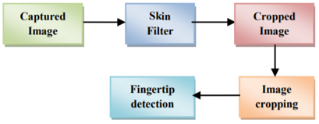

Figure 1.1: Flowchart for depicting Fingertip detection

A lot of work has been done in this area for dynamic hand gesture recognition using fingertip detection. A survey on fingertip-based methods could be found out in. There are several limitations in existing approaches. Garg used 3D images in his method to recognize the hand gesture, but this process is complex and also not time efficient. The Processing time is one of the very critical factors in real time applications. Aznaveh presented an RGB vector-based method for skin detection in images. Yang analyses the hand contour to select fingertip candidates, then finds peaks in their spatial distribution and checks local variance to locate fingertips [6]. This method is not invariant to the orientation of the hand. There are other methods, which are using directionally Variant templates to detect fingertips. Few other methods are dependent on specialized instruments and setup like the use of infrared camera, stereo camera, a fixed background or use of markers on hand. This report describes a novel method of motion patterns recognition generated by the hand without using any kind of sensor or marker.

The fingertips detection should be near to real time if it is going to process video. Generally, image-based models work on pixel by pixel and do hand Segmentation and work only on region of interest [6]. However, most hand segmentation methods can’t do a clearly hand segmentation under some conditions like fast hand motion, cluttered background, poor light condition. If the hand segmentation is not valid, then detection of fingertips can be questionable. Researchers used infrared camera to get a reliable segmentation [10]. Few researchers in their work limit the degree of the background clutter, finger motion speed or light conditions to get a reliable segmentation. Raheja and few others also used 3D mapping using specialized device like KINECT for hand segmentation [2]. Some of fingertip detection methods can’t localize accurately multidirectional fingertips. Researchers assumed that the hand is always pointing upward to get precise localization.

Deaker proposed a piano tutoring system which would test the user’s knowledge by asking them to play particular notes or chords on a paper keyboard with a printed design [4]. Deaker’s proposal is similar to ours in that it requires the detection of the printed keyboard’s individual keys in order to determine if the user has followed instructions correctly. However, Deaker’s design has several limitations, perhaps the most significant of which being that the identification of keys is not entirely achieved by computer vision alone. A particular number of keys are required to be visible to the camera during calibration (14 white keys, starting from a C key and ending on the B key just under two octaves above) and the software assumes that this requirement has been met.

Another computer vision based piano tutor was proposed by Dawe [6]. In this case, the system is intended for relaying a student’s choice of fingering to their teacher during a remote piano lesson. Similarly, to Deaker’s proposal, Dawe’s method requires a calibration stage where the user is required to select a region of interest – in order to narrow the video frames down to the area occupied by the instrument’s keyboard. This brings with it the same limitations imposed by Deaker’s method; that is the camera must remain stationary at all times, and the keyboard must not be obscured during the calibration process.

To find the key locations during the calibration phase, Dawe used horizontal and vertical edge detection to determine the boundaries of the keyboard and its individual keys. Unfortunately, a major limitation of Dawe’s method was that a translation between these detected edges and a description of the location of each key of the keyboard was unable to be implemented.

After examining these proposed methods, it was clear that a satisfactory method of keyboard and key detection had not been found. The following works were more successful in their attempts to detect individual piano keys.

The work by Barakonyi and Schmaltzier demonstrates a variety of 3D augmented reality (AR) applications, including the Augmented Piano Tutor application [2]. The application displays an AR overlay on the user’s electronic keyboard, indicating which keys are to be played.

The method proposed by Gorodnichy and Yogeswaran attempts to solve the same problem as identified by Dawe; that is, Gorodnichy and Yogeswaran present a solution to allow current remote piano teaching systems to communicate fingering information [4]. There is one major limitation of Gorodnichy and Yogeswaran’s method; the camera used is not an off-the-shelf webcam, but instead a more expensive video camera with high quality output and zoom functionality is required.

The final keyboard detection method we shall discuss is from a paper by Huang, Zhou, Yu, Wang and Du [3], where a marker less AR piano system is proposed. The 3D AR result is very similar to that achieved by Barak Onyi and Schmaltzier, although in this case a fiducial marker is not required. To identify the keys of the keyboard, a similar method to that of Gorodnichy and Yogeswaran is employed. After identifying the piano keys, this solution uses OpenGL to augment the video stream with 3D graphics.

This was seemed to accomplish almost all of what we were setting out to achieve. Consequently, the work by Huang, Zhou, Yu, Wang and Du is regarded as a target result for our paper, with our application intended to match the results produced by the marker less AR piano system as best as possible. More specifically, the system by Huang et al. managed the keyboard identification and rendering of the video feed, with overlays, at a frame rate of approximately 15 frames per second [6]. We hoped to match or exceed this performance with our solution.

* + 1. **Problem Statement**

Pianos are large instruments that cannot be carried everywhere. Even electric pianos need to be carried in a large bag and are prone to damage in travelling. So here we propose a portable virtual piano that just uses semi-transparent plastic sheet that can be carried and does not have any electronic components in it.

* + 1. **Goal**

1. Assigning the respective tones of piano to the corresponding segments of Virtual Piano made using a semi-transparent plastic sheet.
2. Real time motion detection of fingers using a camera linked with Raspberry pi.
3. To play the tone assigned to a segment on detection of finger on that particular segment.
   * 1. **Solutions**

As a final note on the system developed by Huang et al., there is a small way in which the design could arguably be improved upon: The marker less AR piano system requires a one-time calibration for each camera and/or piano used, and for the 3D registration to be possible, the dimensions of the keyboard need to be known by the software [13]. This requires that the user manually measure their piano keyboard, then input the information into the AR program. At the expense of 3D augmentations, this potential inconvenience can be removed.

* 1. **Need Analysis**

Piano is almost certainly the largest and most complex mechanical device. A standard piano has 230 strings and about 10,000 separate moving parts. Over the last decade, alternatively sized keyboards have become available in a very limited way. At the same time, various academics, researchers and manufacturers such as Steinbuhler & Company have started to raise awareness and discuss the possibility that the current size keyboard is not ideal for all, and that keyboards with narrower keys may well suit the majority of the population [5]. However, they encounter considerable resistance to contemplate change from the ‘one-size suits all’ mentality. A major disincentive for a pianist wanting to switch to a keyboard of a different size is that they are not available - in practical terms every piano keyboard anywhere is the standard size. Major piano manufacturers do not produce pianos with narrower keys, except perhaps as a rare, ‘special’ order. A handful of small manufacturers can and do, but not in enough supply: small-scale production, logistics and cost prohibit worldwide access. The plight of pianists who do have reduced size keyboards at home illustrates the complexities [7]. While they may reach a very high standard with challenging repertoire on the narrower keys, away from their own keyboard the only option are pianos with the standard keys – meaning that they struggle to play many pieces as well and have to drop some of their repertoire completely. To play outside their home they will need easy access to a 'standard' keyboard for practice – options include a grand piano with interchangeable keyboards or acquiring a standard keyboard in a good quality digital piano. As keyboards with narrower keys become more widely accepted and accessible in the community this problem will be reduced.

With the skyrocketing costs of new pianos over the past decade or two, the prices of used pianos have increased dramatically.  Another upward pressure on the cost of a used piano is that there are fewer good used pianos available.  A large portion of the big old uprights are now old enough that they have serious mechanical problems which cost more to repair than they are worth so they are being scrapped [1].  Many of the less expensive pianos built in the 60's and 70's are also coming to the end of their useful life and are being taken to the dump or scrapped.  15-20 years ago, a really good used piano could be purchased for $ 300-500 and something that held tune and played could be purchased for $ 100-200.

Today, the piano buyer needs to expect to pay a minimum of $ 1,200-1,500 for a piano that will hold tune and plays reasonably well and doesn't look horrible in your living room. Most used pianos that are for sale are on the market because the family has lost interest in playing the piano.  Since there has been no interest in it, it probably has not been tuned or cared for in several years.  The piano buyer needs to keep in mind that they will have to remedy that neglect once the piano is moved to their home [7].  It is possible that the piano has fallen way below standard pitch and will require a pitch raise (see FAQ "What is a Pitch Raise") to bring it back into tune. That pitch raises and 1st tuning could cost close to $ 200.  It is also possible that the piano has not been cleaned or regulated in many years (it is not surprising to find that a piano has NEVER been serviced) so that is doesn't play very smoothly or responsively.  Cleaning and regulating a vertical piano can cost around $ 400.

The greatest risk in purchasing a used piano is in whether it will hold tune or not.  There is much less risk in buying a piano that has been tuned regularly and the service records are available.  That is not a guarantee that it will continue to hold tune in the future but is certainly a good indicator.  The buyer should be willing to pay significantly more for such an instrument than one that has not had any care for a number of years [3]. A piano technician can make an educated guess as to the condition of a piano in a brief visit, but without a history of working with the instrument, it is but an educated guess.

* 1. **Research Gaps**

This piano cannot be used to play complete songs because the piano is being played with the help of finger detection which is done using a camera and while playing a song it is necessary to move our fingers from one piano segment to other piano segment but the constraint in this piano is that when we move our fingers from one segment to other segment, the segments between these two segments are also detected by the camera and thus the tones corresponding to the segments in between is also played. So, this is a research gap as we could not find the solution of this problem in any of the research papers.

* 1. **Problem Definition and Scope**

Moving piano from one home to another without the utmost care can easily cause unforeseen problems. Hence Pianos are large instruments that cannot be carried everywhere. Even electric pianos need to be carried in a large bag and are prone to damage in travelling. Today, the piano buyer needs to expect to pay a minimum of $ 1,200-1,500 for a piano that will hold tune and plays reasonably well and doesn't look horrible in your living room.  Most used pianos that are for sale are on the market because the family has lost interest in playing the piano.

So here we propose a portable virtual piano that just uses semi-transparent plastic sheet that can be carried and does not have any electronic components in it. The solution mainly focuses on the cost and budget of the Music Enthusiastic. Virtual Piano will reduce the problem of carrying large sized pianos. The Scope of the project mainly focuses on the following things: -

1. Large Pianos are prone to damage in travelling and these Virtual Pianos will take care of this issue.
2. Virtual Pianos will be much cheaper than traditional pianos.
3. It will help young children to get a feel for music and will act as a stepping stone for some of the world’s greatest artists.
   1. **Assumptions and Constraints**

|  |  |
| --- | --- |
| **S. No.** | **Assumptions** |
| **1** | Camera should be mounted properly. |
| **2** | The camera should be mounted in such a way such that it focusses on each segment properly. |
| **3** | The camera should be calibrated before the system starts. |
| **4** | The piano should be set up in bright lighting conditions. |
| **5** | The size of the piano will depend on the coverage area of camera. |
| **6** | The system should fulfil all the basic requirements needed for the project. |
| **7** | This piano cannot be used to play complete songs because the piano is being played with the help of finger detection which is done using a camera and while playing a song it is necessary to move our fingers from one piano segment to other piano segment but the constraint in this piano is that when we move our fingers from one segment to other segment, the segments between these two segments are also detected by the camera and thus the tones corresponding to the segments in between is also played. |

Table 1.1: Assumptions and Constraints

* 1. **Approved Objectives**

1. Assigning the respective tones of piano to the corresponding segments of Virtual Piano made using semi-transparent plastic sheet.
2. Real time motion detection of fingers using a camera linked with Raspberry pi.
3. To play the tone assigned to a segment on detection of finger on that particular Segment.
   1. **Methodology Used**

Pianos are large instruments that cannot be carried everywhere. Even electric pianos need to be carried in a large bag and are prone to damage in travelling. So here we propose a portable virtual piano that just uses semi-transparent plastic sheet that can be carried and does not have any electronic components in it. We use a raspberry pi attached to a camera along with the plastic sheet to make a virtual piano. We use image processing to divide the plastic sheet into sections and assign particular tomes to it. We then detect human fingers through the plastic sheet and simulate associate piano tone for each section to play piano tones using a speaker. Thus, we provide a virtual piano which is actually a transparent light weight plastic board that can be carried around roughly [7].

We propose a method for identifying a piano keyboard present in the video footage of a standard webcam with the goal of teaching chords, scales and suggested finger positions to a beginner pianist. Our keyboard identification method makes use of binary thresholding, Sobel operators and Hough transforms, as well as proposed algorithms specific to this application, to first find an area resembling a piano keyboard before narrowing the search to detect individual keys [9]. Through the use of our method the keys of a piano keyboard were successfully identified from webcam video footage, with a tolerance to camera movement and occluded keys demonstrated. This result allowed the augmented reality style highlighting of individual keys, and the display of suggested fingering, for various chords and scales.

* 1. **Project Outcomes and Deliverables**

1. Large Pianos are prone to damage in travelling and these Virtual Pianos will take care of this issue.
2. Virtual Pianos will be much cheaper than traditional pianos.
3. It will help young children to get a feel for music and will act as a stepping stone for some of the world’s greatest artists.
4. Here, we are delivering a portable virtual piano that just uses semi-transparent plastic sheet that can be carried anywhere and does not have any electronic components in it.
   1. **Novelty of Work**

In this project, we are focusing on direction invariant fingertip detection of natural hand with real time performance. This work requires no glove, sensors or color strips to detect the fingertips. The only assumption is that user will show the hand to system, facing the palm to the system while the direction of hand is not restricted. User is free to show hand in any direction as naturally hands move [11]. This report also presents a figure cropping method based on hand size, which will fasten the further process as the processing pixels would be reduced after cropping.

A lot of work has been done in this area for dynamic hand gesture recognition using fingertip detection. A survey on fingertip-based methods could be found out in. There are several limitations in existing approaches. Garg used 3D images in his method to recognize the hand gesture, but this process is complex and also not time efficient. The Processing time is one of the very critical factors in real time applications. Aznaveh presented an RGB vector-based method for skin detection in images. Yang analyses the hand contour to select fingertip candidates, then finds peaks in their spatial distribution and checks local variance to locate fingertips [6]. This method is not invariant to the orientation of the hand. There are other methods, which are using directionally Variant templates to detect fingertips. Few other methods are dependent on specialized instruments and setup like the use of infrared camera, stereo camera, a fixed background or use of markers on hand. This report describes a novel method of motion patterns recognition generated by the hand without using any kind of sensor or marker.

The fingertips detection should be near to real time if it is going to process video. Generally, image-based models work on pixel by pixel and do hand Segmentation and work only on region of interest [6]. However, most hand segmentation methods can’t do a clearly hand segmentation under some conditions like fast hand motion, cluttered background, poor light condition. If the hand segmentation is not valid, then detection of fingertips can be questionable. Researchers used infrared camera to get a reliable segmentation [10]. Few researchers in their work limit the degree of the background clutter, finger motion speed or light conditions to get a reliable segmentation. Raheja and few others also used 3D mapping using specialized device like KINECT for hand segmentation [2]. Some of fingertip detection methods can’t localize accurately multidirectional fingertips.

**REQUIREMENT ANALYSIS**

* 1. **Literature Survey**
     1. **Theory Associated with Problem Area**

A lot of work has been done in this area for dynamic hand gesture recognition using fingertip detection. A survey on fingertip-based methods could be found out in. There are several limitations in existing approaches. Garg used 3D images in his method to recognize the hand gesture, but this process is complex and also not time efficient. The Processing time is one of the very critical factors in real time applications. Aznaveh presented an RGB vector-based method for skin detection in images. Yang analyses the hand contour to select fingertip candidates, then finds peaks in their spatial distribution and checks local variance to locate fingertips. This method is not invariant to the orientation of the hand. There are other methods, which are using directionally Variant templates to detect fingertips. Few other methods are dependent on specialized instruments and setup like the use of infrared camera, stereo camera, a fixed background or use of markers on hand. This paper describes a novel method of motion patterns recognition generated by the hand without using any kind of sensor or marker [8].

The fingertips detection should be near to real time if it is going to process video. Generally, image-based models work on pixel by pixel and do hand Segmentation and work only on region of interest. However, most hand segmentation methods can’t do a clearly hand segmentation under some conditions like fast hand motion, cluttered background, poor light condition [14]. If the hand segmentation is not valid, then detection of fingertips can be questionable. Researchers used infrared camera to get a reliable segmentation. Few researchers in their work limit the degree of the background clutter, finger motion speed or light conditions to get a reliable segmentation. Raheja and few others also used 3D mapping using specialized device like KINECT for hand segmentation. Some of fingertip detection methods can’t localize accurately multidirectional fingertips. Researchers assumed that the hand is always pointing upward to get precise localization.

* + 1. **Existing System and Solutions**

We began by examining the recent papers from the University of Canterbury, where work, similar to that proposed in this paper, has been developed in the past. For example, Lang produced a webcam-based piano application – however the focus of this was on entertainment, not education, and there was no attempt made to detect the keyboard or keys of a real piano [3].

Deaker proposed a piano tutoring system which would test the user’s knowledge by asking them to play particular notes or chords on a paper keyboard with a printed design [4]. Deaker’s proposal is similar to ours in that it requires the detection of the printed keyboard’s individual keys in order to determine if the user has followed instructions correctly. However, Deaker’s design has several limitations, perhaps the most significant of which being that the identification of keys is not entirely achieved by computer vision alone. A particular number of keys are required to be visible to the camera during calibration (14 white keys, starting from a C key and ending on the B key just under two octaves above) and the software assumes that this requirement has been met [5].

Another computer vision based piano tutor was proposed by Dawe [6]. In this case, the system is intended for relaying a student’s choice of fingering to their teacher during a remote piano lesson. Similarly, to Deaker’s proposal, Dawe’s method requires a calibration stage where the user is required to select a region of interest – in order to narrow the video frames down to the area occupied by the instrument’s keyboard. This brings with it the same limitations imposed by Deaker’s method; that is the camera must remain stationary at all times, and the keyboard must not be obscured during the calibration process.

To find the key locations during the calibration phase, Dawe used horizontal and vertical edge detection to determine the boundaries of the keyboard and its individual keys. Unfortunately, a major limitation of Dawe’s method was that a translation between these detected edges and a description of the location of each key of the keyboard was unable to be implemented.

After examining these proposed methods, it was clear that a satisfactory method of keyboard and key detection had not been found. The following works were more successful in their attempts to detect individual piano keys. The work by Barakonyi and Schmaltzier demonstrates a variety of 3D augmented reality (AR) applications, including the Augmented Piano Tutor application [2]. The application displays an AR overlay on the user’s electronic keyboard, indicating which keys are to be played.

Unfortunately, the paper by Barak Onyi and Schmaltzier does not describe their implementation details – making it difficult to learn any lessons from their AR solution. However, some of their high-level implementation is explained, and even from this it is possible to suggest some improvements – albeit minor ones. The Augmented Piano Tutor application makes use of AR Toolkit for 3D registration. The use of AR Toolkit means that a fiducial marker is required as a reference point for the application. It would be most convenient for the user if they did not have to correctly place a marker or do any more than set up their webcam and laptop, to use a tutoring program. An ideal system would allow the user to simply run an application, point their webcam at a keyboard, and begin playing [13].

The method proposed by Gorodnichy and Yogeswaran attempts to solve the same problem as identified by Dawe; that is, Gorodnichy and Yogeswaran present a solution to allow current remote piano teaching systems to communicate fingering information [12]. There is one major limitation of Gorodnichy and Yogeswaran’s method; the camera used is not an off-the-shelf webcam, but instead a more expensive video camera with high quality output and zoom functionality is required.

The final keyboard detection method we shall discuss is from a paper by Huang, Zhou, Yu, Wang and Du, where a marker less AR piano system is proposed. The 3D AR result is very similar to that achieved by Barak Onyi and Schmaltzier, although in this case a fiducial marker is not required [8]. To identify the keys of the keyboard, a similar method to that of Gorodnichy and Yogeswaran is employed. After identifying the piano keys, this solution uses OpenGL to augment the video stream with 3D graphics.

This was a paper that seemed to accomplish almost all of what we were setting out to achieve. Consequently, the work by Huang, Zhou, Yu, Wang and Du is regarded as a target result for our paper, with our application intended to match the results produced by the marker less AR piano system as best as possible. More specifically, the system by Huang et al. managed the keyboard identification and rendering of the video feed, with overlays, at a frame rate of approximately 15 frames per second. We hoped to match or exceed this performance with our solution [6].

As a final note on the system developed by Huang et al., there is a small way in which the design could arguably be improved upon: The marker less AR piano system requires a one-time calibration for each camera and/or piano used, and for the 3D registration to be possible, the dimensions of the keyboard need to be known by the software [2]. This requires that the user manually measure their piano keyboard, then input the information into the AR program. At the expense of 3D augmentations, this potential inconvenience can be removed.

* + 1. **Research Findings for Existing Literature**

|  |  |  |  |  |  |  |
| --- | --- | --- | --- | --- | --- | --- |
| **S. No.** | **Roll Number** | **Name** | **Paper Title** | **Tools/**  **Technology** | **Findings** | **Citation** |
| 1 | 101683035 | Akshay Sharma | Marker-less piano fingering recognition using sequential depth images | Python and OpenCV | Found how camera is recognizing keys to play tone. | Adam Goodwin, Richard Green, “Key detection for a virtual piano teacher”, Image and Vision Computing New Zealand (IVCNZ) 28th International Conference of, pp. 282-287, 2013. |
| 2 | 101683035 | Akshay Sharma | Major Piano Triad Chords | Python and OpenCV | Found how real time sensing helps to play the associated piano tone. | Mohammad Akbari, Howard Cheng, “Real-Time Piano Music Transcription Based on Computer Vision”, Multimedia IEEE Transactions on, vol. 17, no. 12, pp. 2113-2121, 2015. |
| 3 | 101683035 | Akshay Sharma | An intelligent virtual piano tutor | MATLAB and OpenCV | Found how computer vision helps to recognize fingers. | Chutisant Kerdvibulvech, *Augmented Reality, Virtual Reality, and Computer Graphics*, vol. 10325, pp. 251, 2017. |
| 4 | 101683035 | Akshay Sharma | A Computer Vision Method of Piano Tutoring | Python | Found how Raspberry pi works for real time motion of fingers with the help of the camera. | D. Schwarz, S. Britton, R. Cahen, T. Goepfer. Musical Applications of Real-Time Corpus-Based Concatenative Synthesis. International Computer Music Conference (ICMC) (Copenhagen, Denmark), pp. 23, 2007. |
| 5 | 101683035 | Akshay Sharma | Virtual Piano Design via Single-View Video Based on Multifinger Actions Recognition | MATLAB | Found what should be the positioning of the keys and how to optimize the speed of sensing. | A. Freed and R. Avizienis, “A new music keyboard featuring continuous key-position sensing and high-speed communication options,” in Proceedings of the International Computer Music Conference, Berlin, Germany, 2000. |
| 6 | 101683035 | Akshay Sharma | Computer Vision Piano Tutor | Python, Adafruit | Found how a real time system actually works for playing piano music. | Mohammad Akbari, Jie Liang, Howard Cheng, “A real-time system for online learning-based visual transcription of piano music”, Multimedia Tools and Applications, vol. 77, pp. 25513, 2018. |
| 7 | 101503008 | Abhishek Sharma | A Markerless Augmented Reality Based Piano Teaching System | MATLAB | Found how we can detect multifinger gesture sensing to play associated piano tone. | Multidimensional gesture sensing at the piano keyboard,” in Proceedings of the 29th ACM Conference on Human Factors in Computing Systems (CHI), Vancouver, Canada, pp. 72, 2011 |
| 8 | 101503008 | Abhishek Sharma | The Size of the Piano Keyboard | Python | Found how keyboard piano works. | L. Haken, E. Tellman, and P. Wolfe, “An indiscrete music keyboard,” Computer Music Journal, vol. 22, no. 1, pp. 30–48, 1998. |
| 9 | 101503008 | Abhishek Sharma | PianoTouch: A wearable haptic piano instruction system for passive learning of piano skills | Python, Adafruit | Found what are the problems we have to face in virtual piano like we need good lightning conditions. | Boga Vishal, K Deepak Lawrence, “Paper piano — Shadow analysis-based touch interaction”, Man and Machine Interfacing (MAMI) 2nd International Conference on, pp. 1-6, 2017. |
| 10 | 101503008 | Abhishek Sharma | Computer vision method for pianist’s fingers information retrieval | Python, OpenCV | Found how camera will detect keys frame by frame using image processing | Adam Goodwin, Richard Green, “Key detection for a virtual piano teacher”, Image and Vision Computing New Zealand (IVCNZ) 28th International Conference of, pp. 282-287, 2013 |
| 11 | 101503008 | Abhishek Sharma | Musical Desktop: A Webcam Piano | Structured Query Language | Found how raspberry pi fetches the correct tone from the database. | C. von Hardenberg, F. Berard, “Bare-hand human-computer interaction”, Proceedings of the 2001 workshop on Perceptive user interfaces*,* pp. 1-8, 2001. |
| 12 | 101503008 | Abhishek Sharma | Detection and tracking of pianist hands and fingers | MATLAB | Found how to take accurate measurement of moving fingers in real time. | T. Yang, S. Z. Li, Q. Pan, J. Li, “Real-time and accurate segmentation of moving objects in dynamic scene”, Proceedings of the ACM 2nd international workshop on Video surveillance & sensor networks, pp. 136-143, 2004. |

Table 2.1: Research Findings for Existing Literature

* + 1. **Problem That Has Been Identified**

Moving piano from one home to another without the utmost care can easily cause unforeseen problems. Hence Pianos are large instruments that cannot be carried everywhere. Even electric pianos need to be carried in a large bag and are prone to damage in travelling.

Today, the piano buyer needs to expect to pay a minimum of $1,200-1,500 for a piano that will hold tune and plays reasonably well and doesn't look horrible in your living room. Most used pianos that are for sale are on the market because the family has lost interest in playing the piano.

So here we propose a portable virtual piano that just uses semi-transparent plastic sheet that can be carried and does not have any electronic components in it. The solution mainly focuses on the cost and budget of the Music Enthusiastic [14]. Virtual Piano will reduce the problem of carrying large sized pianos.

* + 1. **Survey of Tools and Technology Used**

Video is the sequence of the image frames at a fixed rate. First of all, Images would be captured with a simple camera in 2D continuously and would be processed one by one. An HSV colour space-based skin filter would be applied on the images for hand segmentation. An intensity-based histogram would be constructed for the wrist end detection and image would be cropped so that resultant image would have only hand pixels. The fingertips would be detected in the cropped hand image and would be marked differently [1].

**Skin Filter**

An HSV colour space-based skin filter would be used on the current image frame for hand segmentation. The skin filter would be used to create a binary image with black background. This binary image would be smoothened using the averaging filter. There can be false positives, to remove these errors the biggest BLOB (Binary Linked Object) is considered as the hand and rest are background. The biggest BLOB represents hand coordinates “1” and “0” to the background [4]. The filtered-out hand image, after removing all errors. The only limitation of this filter is that the BLOB for hand should be the biggest one.

**Wrist End Detection**

To crop the image, we need to find out the direction of hand and wrist end. First of all, an intensity histogram of the binary silhouette would be formed. Histograms functions are: Here imb represents the binary silhouette and m, n represents the row and columns of the matrix imb.

Hx =

Hy =

To find the direction of hand, after a 4-way scan of image, we choose the maximum value of on pixels coming out of all scans (“1” in the binary silhouette). it was noted that maximum value of “ON” pixels represents wrist end and opposite end of this scan end would represent the finger end. Similarly, the green bar corresponds to right scan, red bar corresponds to down scan, and pink bar corresponds to up scan of „on‟ pixels in the binary silhouette [2]. Now, it is clear that red bar has higher magnitude than other bars. So, we can infer that the wrist end is in downward direction of the frame and consequently the direction of fingers is in the upward direction [8]. Here the direction from wrist to finger is known.

**Hand Cropping**

Hand cropping minimizes the number of pixels to be considered for processing which leads to minimization of computation time. In the histogram generated, it was observed that at the point where wrist ends, a steeping inclination of the magnitude of the histogram starts, whose slope, m can be defined as:

m = $\frac{y2-y1}{x2-x1}$

The scan would start from the end where skin pixel was found and move till an inclination would be found. The points correspond to the first skin pixel scanning from other three sides were found, crop the image at that points. The equations for cropping the image are:

imcrop = $\left\{\begin{aligned}origin_{image}, for Xmin<X<Xmax \\ \\ 0 elsewhere\end{aligned}\right\}$

Where imcrop represents the cropped image, Xmin, Ymin, Xmax, Ymax represent the boundary of the hand in the image. Some results with processing steps for hand cropping. The arrows showed in the main frames indicate the direction of scan which was found from wrist end detection step [7]. In all the histograms it is clear that at the wrist point, a steeping inclination starts in the scanning direction.

**Fingertip Detection**

At this point we have one smaller image which conation only skin pixels (hand gesture shape). We will figure out fingertips in the cropped hand image. Start scan the cropped binary image from wrist to fingers end and calculate the number of pixels for each row or column based on the hand direction in up-down or left-right. Assign the intensity values for each pixel from 1 to 255 in increased manner from wrist to finger end in equal distribution [5]. So, each “on” pixel on the edges of the fingers would be assigned a high intensity value of 255. Hence all the fingertips contain pixel value 255. The fingertip detection can be represented mathematically as;

pixelcount(y) = $\sum_{X=Xmin}^{Xmax}{imb(x,y)}$

modified_image (x, y) = round(x*255/pixelcount(y))

Fingeredge(x,y) = $\left\{\begin{aligned} \\ 1 if modified_{image}\left(x,y\right)=255 \\ \\ 0 otherwise \\ \end{aligned}\right.$

The line having high intensity pixel, is first indexed and check whether differentiated value lie inside a threshold, if it is then it represents a fingertip. The threshold value changes toward the direction of hand. That threshold can be set after the detection of the direction of hand to the finger which we already know. where detected pixels are marked with different color. any direction, only palm should face the camera [11]. The fingertips would be detected irrespective of user orientation. The movement of user’s finger will control the robot hand and its working, by moving hand in front of camera without wearing any gloves or markers.

* 1. **Standards**

**Industry 4.0:** Industry 4.0 is a name given to the current trend of [automation](https://en.wikipedia.org/wiki/Automation) and data exchange in [manufacturing](https://en.wikipedia.org/wiki/Manufacturing) [technologies](https://en.wikipedia.org/wiki/Technologie). It includes [cyber-physical systems](https://en.wikipedia.org/wiki/Cyber-physical_system), the [Internet of things](https://en.wikipedia.org/wiki/Internet_of_things), [cloud computing](https://en.wikipedia.org/wiki/Cloud_computing) and [cognitive computing](https://en.wikipedia.org/wiki/Cognitive_computing). Industry 4.0 is commonly referred as the [fourth industrial revolution](https://en.wikipedia.org/wiki/Fourth_Industrial_Revolution). Industry 4.0 fosters what has been called a "smart factory". Within modular structured smart factories, cyber-physical systems monitor physical processes, create a virtual copy of the physical world and make decentralized decisions. Over the Internet of Things, cyber-physical systems communicate and cooperate with each other and with humans in real-time both internally and across organizational services offered and used by participants of the [value chain](https://en.wikipedia.org/wiki/Value_chain).

* 1. **Software Requirements Specification**
     1. **Introduction**
        1. **Purpose**

We propose a portable virtual piano that just uses semi-transparent plastic sheet that can be carried anywhere and does not have any electronic components in it. Large Pianos are prone to damage in travelling and these Virtual Pianos will take care of this issue. Virtual Pianos will be much cheaper than traditional pianos. It will help young children to get a feel for music and will act as a stepping stone for some of the world’s greatest artists.

* + - 1. **Intended Audience and Reading Suggestion**

1. Developers who can review project’s capabilities and more easily understand where their efforts should be targeted to improve or add more features to it (design and code the application – it sets the guidelines for future development).
2. Project testers can use this document as a base for their testing strategy as some bugs are easier to find using a requirements document. This way testing becomes more methodically organized.
3. End users of this application who wish to read about what this project can do.
   * + 1. **Project Scope**

Moving piano from one home to another without the utmost care can easily cause unforeseen problems. Hence Pianos are large instruments that cannot be carried everywhere. Even electric pianos need to be carried in a large bag and are prone to damage in travelling. Today, the piano buyer needs to expect to pay a minimum of $ 1,200-1,500 for a piano that will hold tune and plays reasonably well and doesn't look horrible in your living room.  Most used pianos that are for sale are on the market because the family has lost interest in playing the piano.

So here we propose a portable virtual piano that just uses semi-transparent plastic sheet that can be carried and does not have any electronic components in it. The solution mainly focuses on the cost and budget of the Music Enthusiastic. Virtual Piano will reduce the problem of carrying large sized pianos. The Scope of the project mainly focuses on the following things: -

1. Large Pianos are prone to damage in travelling and these Virtual Pianos will take care of this issue.
2. Virtual Pianos will be much cheaper than traditional pianos.
3. It will help young children to get a feel for music and will act as a stepping stone for some of the world’s greatest artists.

* + 1. **Overall Description**
       1. **Product Perspective**

Virtual reality is all about bringing your imagination into existence. our focus is to create virtual- reality-based-products, and bring the concept of "conceptualize and virtualize". "virtual piano" expanding to " virtual piano " is one of our products that limelight this concept by allowing users to play piano by just touching on a 2d piano image. cooked on the base of computer vision, with extracts of python and essence of image processing makes it a full-fledged techno-pie that brings virtual reality and shows its advantages. Virtual piano, sees the image of piano in real world using a webcam, implemented using python computer vision and when a user touches on image the roi (region of interest) is calculated using image processing that which key is pressed by finger (based on a unique centroid based pattern matching algorithm) and accordingly the corresponding frequency of that note is determined and corresponding sound is played. This explains that innovation and technology is what matters for virtual piano [2]. Thus, we are allowing users to eliminate the use of hardware and use virtual reality to play piano anywhere, anytime by just touching its image. our basic strategy is to eliminate the use of hardware by infusing life in images using virtual reality. Hence virtual piano will bring a total revolution in the music industry through the use of technology. It can be used as a midi keyboard also and thus finds its scope in the music industry [9].

**Necessity**

The need for the product is recognized.The decision to provide the product is made.The scope of the product is determined.The requirements for the product are gathered.

**Invention**

The product is designed from the requirements.The product is created from the design.The product is documented and undergoes testing

**Release**

The product is packaged for outside release.The product goes through further steps of external testing. The product may be handed off to an operational group.

**Support**

An operational group may support the product.A user service group may support the product. Development may support operations.Development will support the code.

**DE support**

The lack of need for the product is recognized.The product may be phased out entirely,or support may transition to a different product.

* + - 1. **Product Features**

Music has always been an important part of worship for Latter-day Saints. It inspires and strengthens, brings beauty and unity, and is a unique way to express feelings about the gospel. Many Church members want to learn how to read music, conduct hymns, and play a keyboard instrument. The purpose of the Basic Music Course is to help you develop these skills. As you do, you will enrich your life and be able to serve in new ways. The Basic Music Course has two parts: The Conducting Course and the Virtual Piano Course. You do not need previous musical training to begin these courses. As you progress through them, you will learn music skills in a carefully planned order. You should begin with the Conducting Course. After completing it, you will know the basics of rhythm and note reading; you will also know how to use the Church hymnbook and conduct most hymns. After completing the Virtual Piano Course, you will know how to read music and play some simple hymns on an instrument [7]. The Basic Music Course can be used in branches, wards, stakes, and homes to teach all interested members and nonmembers. No fees beyond the cost of materials should be charged.

We propose a method for identifying a piano keyboard present in the video footage of a standard webcam with the goal of teaching chords, scales and suggested finger positions to a beginner pianist. Our keyboard identification method makes use of binary thresholding, Sobel operators and Hough transforms, as well as proposed algorithms specific to this application, to first find an area resembling a piano keyboard before narrowing the search to detect individual keys. Through the use of our method the keys of a piano keyboard were successfully identified from webcam video footage, with a tolerance to camera movement and occluded keys demonstrated [5]. This result allowed the augmented reality style highlighting of individual keys, and the display of suggested fingering, for various chords and scales.

* + 1. **External Interface Requirements**
       1. **Hardware Interfaces**

**LCD Display**

Frequently, an 8051 program must interact with the outside world using input and output devices that communicate directly with a human being. One of the most common devices attached to an 8051 is an LCD display. Some of the most common LCDs connected to the 8051 are 16x2 and 20x2 displays. This means 16 characters per line by 2 lines and 20 characters per line by 2 lines, respectively.

Fortunately, a very popular standard exists which allows us to communicate with the vast majority of LCDs regardless of their manufacturer. The standard is referred to as HD44780U, which refers to the controller chip which receives data from an external source (in this case, the 8051) and communicates directly with the LCD.

[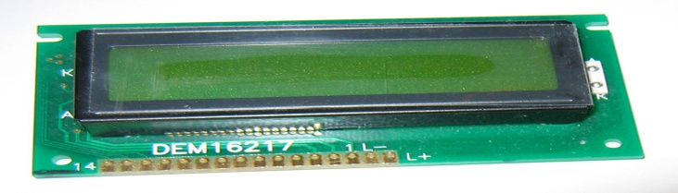](http://upload.wikimedia.org/wikipedia/commons/2/24/LCD_display_16x2_alphanumeric.jpg)

Figure 2.1: LCD Display

**Raspberry Pi**

The Raspberry Pi 3 is a low cost, credit-card sized computer that plugs into a computer monitor or TV, and uses a standard keyboard and mouse. It is a capable little device that enables people of all ages to explore computing, and to learn how to program in languages like Scratch and Python. It’s capable of doing everything you’d expect a desktop computer to do, from browsing the internet and playing high-definition video, to making spreadsheets, word-processing, and playing games.

The Raspberry Pi 3 is the third generation Raspberry Pi. It replaced the Raspberry Pi 2 Model B in February 2016. Compared to the [Raspberry Pi 2](https://www.raspberrypi.org/products/raspberry-pi-2-model-b/) it has:

1. A 1.2GHz 64-bit quad-core ARMv8 CPU
2. 802.11n Wireless LAN
3. Bluetooth 4.1
4. Bluetooth Low Energy (BLE)

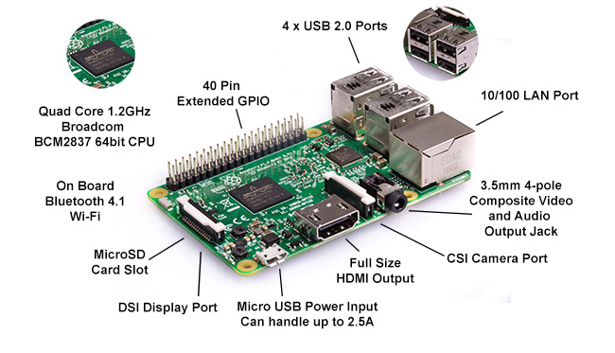

Figure 2.2: Raspberry Pi

**Plastic Sheet**

We have used a semi-transparent plastic sheet for making this project. This plastic sheet is basically displaying us the seven keys of our piano i.e. C, D, E, F, G, A and B. The plastic sheet is basically serving as a replacement of actual piano. This plastic sheet is just used to give people a feel of real piano as there is no need for using this plastic sheet for constructing our Virtual Piano. We have basically used Image Processing to divide our plastic sheet into different segments so whether we use the plastic sheet or not is just a matter of our choice.

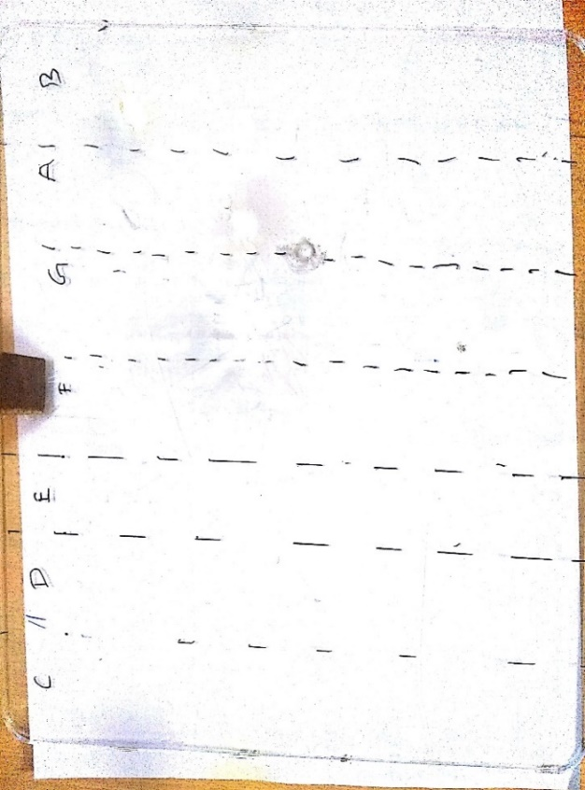This plastic sheet is made up of rigid and semi-transparent material of size 8 inch * 10 inch and thickness 0.5 cm. It is basically used to support the wooden stick on which camera is mount.

Figure 2.3: Plastic Sheet

**Speaker**

A simple speaker has been used for playing the tones which have been simulated for each section by detecting human fingers through the plastic sheet.

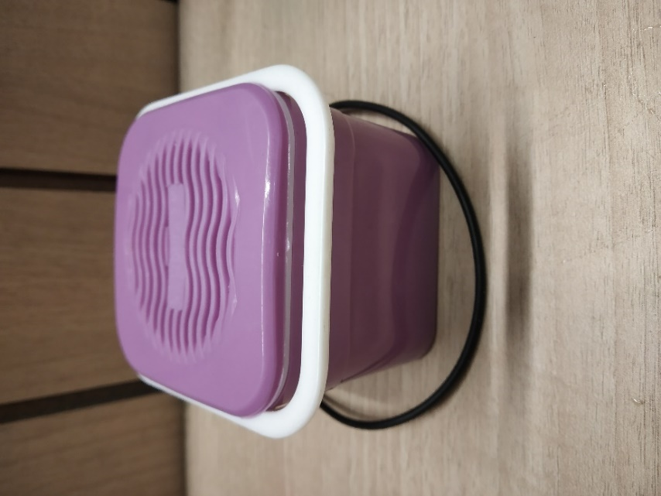

Figure 2.4: Speaker

* + - 1. **Software Interfaces**

IDLE is Python’s Integrated Development and Learning Environment.

IDLE has the following features:

1. Coded in 100% pure Python, using the tkinter GUI toolkit.
2. Cross-platform: works mostly the same on Windows, Unix, and Mac OS X.
3. Python shell window (interactive interpreter) with colorizing of code input, output, and error messages.
4. Multi-window text editor with multiple undo, Python colorizing, smart indent, call tips, auto completion, and other features.
5. Search within any window, replace within editor windows, and search through multiple files (grep).
6. Debugger with persistent breakpoints, stepping, and viewing of global and local namespaces.
7. Configuration, browsers, and other dialogs.

Python is a wonderful and powerful programming language that's easy to use (easy to read and write) and with Raspberry Pi lets you connect your project to the real world. Python syntax is very clean, with an emphasis on readability and uses standard English keywords. Start by opening IDLE from the desktop.

The easiest introduction to Python is through IDLE, a Python development environment. Open IDLE from the Desktop or applications menu:

IDLE gives you a REPL (Read-Evaluate-Print-Loop) which is a prompt you can enter Python commands in to. As it's a REPL you even get the output of commands printed to the screen without using print.

* + 1. **Other Non-functional Requirements**
       1. **Performance Requirements**

The only way in which systems will meet their performance targets is for them to be specified clearly and unambiguously. It is a simple fact that if performance is not a stated criterion of the system requirements then the system designers will generally not consider performance issues. While loose or incorrectly defined performance specifications can lead to disputes between clients and suppliers. In many cases performance requirements are never ridged as system that does not fully meet its defined performance requirements may still be released as other consideration such as time to market.

In order to assess the performance of a system the following must be clearly specified:

1. Response Time
2. Workload
3. Scalability
4. Platform

**Response Time**

In some cases, the system response times are clearly identified as part of a business case for example a criminal’s fingerprint need to be identified while the criminal is still in custody (less than an hour). In some cases, the response time will be dictated by legal requirements although this is rare.

For general applications asking users to what is an acceptable response time is like asking people how much salary they require!! The whole process is simply a process of negotiation.

The general advice on response time from Jakon Nielsen book on Usability is:

0.1 second is about the limit for having the user feel that the system is reacting instantaneously, meaning that no special feedback is necessary except to display the result. 1.0 second is about the limit for the user’s flow of thought to stay uninterrupted, even though the user will notice the delay. Normally, no special feedback is necessary during delays of more than 0.1 but less than 1.0 second, but the user does lose the feeling of operating directly on the data. 10 seconds is about the limit for keeping the user’s attention focused on the dialogue [11]. For longer delays, users will want to perform other tasks while waiting for the computer to finish, so they should be given feedback indicating when the computer expects to be done. Feedback during the delay is especially important if the response time is likely to be highly variable, since users will then not know what to expect.

For systems that have to support significant numbers of users the cost of response times delays can actually be measured in monetary terms and therefore can form part of trade-off studies between different architectures providing different levels of performance.

Whatever is chosen must be measurable in the real system. Care must be taken to ensure that the performance measurement is unambiguous, concise and completely defined. Response time specification should include the following information: Measurement Points: The points at which you want the response time measured needs to be included. For example, are you interested in response time at the data center or from a branch network?  
What is included: Define what is included in the measurement. For example, does the measure for a web page include the browser render time or just the delivery time to the browser?

What is excluded: Ensure calls to 3rd parties beyond the control of the system developer are defined. This is particularly important when defining contractual response time requirements, as suppliers can only be responsible for areas they can influence.

Statistic Type: The statistic type needs to be defined. For example, 95% of all response time should be less than 8.5 second.

Measurement Period: Define the period over which to measure the response time. This is particularly important where workload varies over the day.

Platform: Should it not be possible to test on the real production hardware any allowance for testing on test hardware needs to be stated.

Error Rate: Define the acceptable error rate allowed during the measurement of the response times. Some systems may produce errors under high workloads and therefore the acceptable error rate need to be defined.

Finally, once you have defined the response times have them reviewed by somebody else to check if the definition is indeed clear and unambiguous. Remember also to state the workload at which the response time are to be met.

**Workload**

Again, the business case or existing process should be the start of the workload definition. However, it is not enough to state that “the system should be capable of supporting 80,000 customers” or “the system should be able to support 4 pages/sec”. These statements are often good metrics at a high-level management level but do not define the work that the system must support. This is particularly important as the mix of transaction affects the performance. For example, a DB system may easily handle 10,000 read transaction per hour but only 3,000 update transactions per hour.

The most likely transactions to specify are the user-initiated transactions but care must be taken to consider all the users of the system and the batch processes.

For example, a system may have external customers, internal staff providing data entry and batch processes such as backups. If the backup is not completed overnight, then it may seriously disrupt the performance experienced by the users the next day.

The workload is often described as the scenarios that the users are likely to execute. The table below is an example that shows for a user scenario how many requests per day, what pages a user executes and the think time between pages. You will notice that a percentage is included before the exit page, this is to specify that only a percentage of users will view that page.

When completing a workload specification, a check must be made to ensure that all relevant functions have been covered. This includes not just the obvious user workloads but special cases such as management requests, backups and error scenarios/handling. Once all loads have been considered, infrequent or inappropriate workloads can be eliminated. Inappropriate workloads might include error scenarios where it is understood that errors will be very infrequent although it should be appreciated that an appreciable workload can result from the need to provide adequate error and/or security logging.

The workload should be specified up to the date that you wish current hardware to support without upgrade.

The performance of the system is dependent on how the load is delivered to the system. For example, it is easier to achieve faster response times for a system that receive a regular arrival of work throughout the day compared to one that receive burst of traffic. Therefore, it is important that the workload profile is defined

The arrival rate into the system is rarely going to be constant throughout the day or the week. The figure below shows the arrival rate for requests to a website.

As can be seen in the figure the workload peaks around lunchtime and late evening but activity is very quiet during the night. The above example shows how workload varies over a 24-hour period but it may be more important to show how workload varies over a month for example batch or over an hour for example end of day share trading.

Many organizations’ workload may suffer a rare or unexpected increase in the workload of the system and this is often referred to as a “peak” workload. The decision facing system developers is whether to design a system to cope with a peak workload. The answer to this will depend on the consequence of failing. For example, certain organizations design for a peak. The NY stock exchange in 1997 could process 3 billion transactions in a day while the daily average is less than 1.2 billion (Times, August 14 1997). This is because of the need to execute trades the same day and to maintain an accurate record of the state of the market.

When defining the workload for a new venture and little or no existing workload data exists and the system is to be developed by a supplier the temptation is to specify a high peak workload. This is a valid but often an expensive approach which may still not protect you from high demand as it can still be higher than you specify! An alternative solution is to specify the workload as your business model and analysis predicts it will be. Next, have a detailed specification of the scalability of the system to ensure that the supplier develops a system that is scalable quickly. Specify requirements for detecting and processing overload to ensure flood control mechanisms are in place to avoid the system crashing under intensive loads. Test that the system is scalable by renting in additional equipment or using vendors test environments. Finally ensure the operational staff have a procedure for increasing the scalability of the site and contracts are in place for additional hardware/bandwidth etc.

**Scalability**

In one respect scalability is simply specified as the increase in the system’s workload that the system should be able to process. The scalability required is often driven by the lifespan and the maturity of the system. For example, a new (and hence immature) system could suffer an unexpected growth in popularity and suffer from a significant increase in workload as it becomes popular with new users. More mature systems which represent improvements on older systems are likely to have more accurately defined workloads and thus be less likely to suffer in this respect, remember to specify that the response time requirements should still be meet as the workload scales [10]. A problem with scalability specification is that it may not be economically viable to test the scalability, as it often requires additional hardware. Therefore, an alternative is either to rent in the additional hardware for the purpose of the tests or to use an extrapolation technique such as a simulation model.

**Platform**

A platform is defined as the underlying hardware and software (operating system and software utilities) which will house the system. It is not always the case that the designer will be given a “green field” choice of what platform on which to house the system. In some cases, the customer may dictate this choice or there may be internal reasons (product strategy perhaps) that will constrain the designer’s freedom. It may also be the case that the system will require various generic products to be used in which case the performance of these must also be specified [3].

Consideration must be given as to whether the hardware will be used exclusively for the system or whether it must be shared with some other process. A new system might have to compete with an old system for the processor and its resources. The processor and resource requirements of the old system must be specified so the amount of free space and performance can be assessed.

When the customer specifies the platform for the system it is not only important that the project engineer knows what has been specified but that they also understand its capability in terms of performance [6].

When part of the platform consists of external resources such as connections to external databases or banking systems then the response times of these external resources must also be specified.

* + - 1. **Safety Requirements**

1. Do not touch Raspberry Pi or any component on the PCB board with wet hands.
2. The setup should be prevented from any water spill.
3. There are limited power requirements. The supply should not be more than 5A.
4. The system should be dismantled properly after using the piano.
5. All the components should be kept at one place as there are many small components like micro sd card and if any one of them is misplaced, it will create a huge problem.
6. The system as a whole should be handled with care.
   * + 1. **Security Requirements**

The analysis is the most essential activity to obtain the understanding between the development team and the business team. It maps the information to develop systems/applications in accordance to business and user needs, provided by stakeholders as high-level statements on features and functionalities.

In order to cover security aspects, it is necessary to bring together business, development and security teams to understand the key sensitivities and business consequences caused by risk of security flaws. Since SDLC is a feed forward process and errors introduced in this phase will be spread in the next development phases, it is important to analyze security risks at very early stages.

Currently security requirements are categorized as nonfunctional requirements, which are usually defined as attributes of the software, skipping to be mapped to proper functional requirements and therefore, may not built into the software neither tested appropriately. However, what is the security impact if the security requirements are not captured or defined? Probably the result application may not be assessed for success or failure prior to implementation. Map the nonfunctional to functional requirements, the security requirements become a part of the overall requirements analysis process and, in this case, if conflicts are inevitable than they need to be identified and treated properly.

To show how this discussion has high security impact for application, the IATAC published the report Software Security Assurance (Goertzel, et al., 2007) where the authors met the main security-specific issues involved in requirements engineering, among them:

1. The people involved are not likely to know or care about non-functional requirements. Stakeholders tend to take for granted non-functional security needs.
2. Traditional techniques and guidelines tend to be more focused on functional requirements.
3. Security controls are perceived to limit functionality or interfere with usability.
4. Stakeholders must understand the threats facing a system in order to build defenses against them.
5. The users who help define the system are not typically the abusers from whom the system must be protected.
6. It is more difficult to specify what a system should not do than what it should do.
   1. **Cost Analysis**

|  |  |  |  |
| --- | --- | --- | --- |
| **Raspberry PI:** | ₹ 3,649.00 | **Digital Multimeter:** | ₹ 250.00 |
| **PCB Board:** | ₹ 185.00 | **LCD Display**: | ₹ 1410.00 |
| **SD Card:** | ₹ 599.00 | **Wire stripper & cutter**: | ₹ 58.00 |
| **Speaker:** | ₹ 200.00 | **Miscellaneous:** | ₹ 399.00 |
| **Webcam:** | ₹ 850.00 |  |  |
| **Soldering Iron:** | ₹ 299.00 |  |  |
| **Total** | ₹ 7899.00 | | |

Table 2.2: Cost Analysis

* 1. **Risk Analysis**

The risk analysis process follows the USACE Headquarters requirements as well as the guidance provided by the Cost Engineering Directory of Expertise for Civil Works (Cost Engineering DX). The risk analysis process reflected within the risk analysis report uses probabilistic cost and schedule risk analysis methods within the framework of the Crystal Ball software. The risk analysis results are intended to serve several functions, one being the establishment of reasonable contingencies reflective of an 80 percent confidence level to successfully accomplish the project work within that established contingency amount. Furthermore, the scope of the report includes the identification and communication of important steps, logic, key assumptions, limitations, and decisions to help ensure that risk analysis results can be appropriately interpreted [1].

Risk analysis results are also intended to provide project leadership with contingency information for scheduling, budgeting, and project control purposes, as well as provide tools to support decision making and risk management as the project progresses through planning and implementation. To fully recognize its benefits, cost and schedule risk analyses should be considered as an ongoing process conducted concurrent to, and iteratively with, other important project processes such as scope and execution plan development, resource planning, procurement planning, cost estimating, budgeting, and scheduling [3].

Identifying the risk factors via the PDT are considered a qualitative process that results in establishing a risk register that serves as the document for the further study using the Crystal Ball risk software. Risk factors are events and conditions that may influence or drive uncertainty in project performance. They may be inherent characteristics or conditions of the project or external influences, events, or conditions such as weather or economic conditions. Risk factors may have either favorable or unfavorable impacts on project cost and schedule.

Checklists or historical databases of common risk factors are sometimes used to facilitate risk factor identification. However, key risk factors are often unique to a project and not readily derivable from historical information. Therefore, input from the entire PDT is obtained using creative processes such as brainstorming or other facilitated risk assessment meetings. In practice, a combination of professional judgment from the PDT and empirical data from similar projects is desirable and is considered.

A formal PDT meeting was held at the RAY Building in St. Louis, Missouri, for the purpose of identifying and assessing risk factors. The meeting on March 1, 2010 included the Project Manager, Real Estate, Environmental member, Cost Engineer, and Hydraulic Engineer/Technical Manager Geotechnical Engineer, Cost Engineer, and Hydraulic Engineer/Technical Manager [9].

The first half of the formal meeting focused on risk factor identification using brainstorming techniques and some facilitated discussions based on risk factors common to projects of similar scope and geographic location. The second half of the formal meeting focused on risk factor assessment and quantification.

Additionally, numerous calls and informal meetings were conducted throughout the risk analysis process on an as-needed basis to further facilitate risk factor identification, market analysis, and risk assessment.

The quantitative impacts of risk factors on project plans are analyzed using a combination of professional judgment, empirical data, and analytical techniques. Risk factor impacts are quantified using probability distributions (density functions), because risk factors are entered into the Crystal Ball software in the form of probability density functions. Similar to the identification and assessment process, risk factor quantification involves multiple project team disciplines and functions. However, the quantification process relies more extensively on collaboration between cost engineering, designers, and risk analysis team members with lesser inputs from other functions and disciplines [2].

The following is an example of the PDT quantifying risk factor impacts by using an iterative, consensus-building approach to estimate the elements of each risk factor:

1. Maximum possible value for the risk factor.
2. Minimum possible value for the risk factor.
3. Most likely value (the statistical mode), if applicable.
4. Nature of the probability density function used to approximate risk factor uncertainty.
5. Mathematical correlations between risk factors.
6. Affected cost estimate and schedule elements.

Contingency is analyzed using the Crystal Ball software, an add-in to the Microsoft Excel format of the cost estimate and schedule. *Monte Carlo* simulations are performed by applying the risk factors (quantified as probability density functions) to the appropriate estimated cost and schedule elements identified by the PDT [3]. Contingencies are calculated by applying only the moderate and high-level risks identified for each option (i.e., low-level risks are typically not considered, but remain within the risk register to serve historical purposes as well as support follow-on risk studies as the project and risks evolve).

For the cost estimate, the contingency is calculated as the difference between the P80 cost forecast and the base cost estimate. Each option-specific contingency is then allocated on a civil works feature level based on the dollar-weighted relative risk of each feature as quantified by *Monte Carlo* simulation. Standard deviation is used as the feature-specific measure of risk for contingency allocation purposes. This approach results in a relatively larger portion of all the project feature cost contingency being allocated to features with relatively higher estimated cost uncertainty.

For schedule contingency analysis, the option schedule contingency is calculated as the difference between the P80 option duration forecast and the base schedule duration.

These contingencies are then used to calculate the time value of money impact of project delays that are included in the presentation of total cost contingency in section 6. The resulting time value of money, or added risk escalation, is then added into the contingency amount to reflect the USACE standard for presenting the “total project cost” for the fully funded project amount.

Schedule contingency is analyzed only on the basis of each option and not allocated to specific tasks. Based on Cost Engineering DX guidance, only critical path and near critical path tasks are considered to be uncertain for the purposes of contingency analysis.

**METHODOLOGY ADOPTED**

* 1. **Investigative Techniques**

|  |  |  |  |
| --- | --- | --- | --- |
| **S. No.** | **Investigative Projects Techniques** | **Investigative Techniques Description** | **Investigative Projects Examples** |
| 1 | Descriptive | An investigation was performed in which several real time motion detection algorithms were discussed in detail and after applying different algorithms for our cause, the best one was chosen. | We propose a portable virtual piano that just uses semi-transparent plastic sheet that can be carried and does not have any electronic components in it. Algorithms used are Skin filter, Wrist end detection, Hand cropping, Fingertip Detection. |
| 2 | Comparative | Investigations were made here that compared the output of our Virtual Piano with the actual Piano and we were getting the desired output. | Over the past decades, many electronic music controllers have been developed, but few approaches the ubiquity of the piano-style keyboard. Few Algorithms on which keyboard piano works are Raw data frame, Multi-key gestures, Gestural feature extraction. |
| 3 | Experimental | Experiment is performed on different test cases such as single finger detection, double finger detection and multi finger detection and the same is verified through LCD Display. | Internet of Things, Augmented Reality and Artificial Intelligence based Projects etc. |

Table 3.1: Investigative Techniques

* 1. **Proposed Solution**

Here we propose a portable virtual piano that just uses semi-transparent plastic sheet that can be carried and does not have any electronic components in it. We use a raspberry pi attached to a camera along with the plastic sheet to make a virtual piano. We use image processing to divide the plastic sheet into sections and assign particular tomes to it. We the detect human fingers through the plastic sheet and simulate associate piano tone for each section to play piano tones using a speaker. Thus, we provide a virtual piano which is actually a transparent light weight plastic board that can be carried around roughly.

* 1. **Work Breakdown Structure**

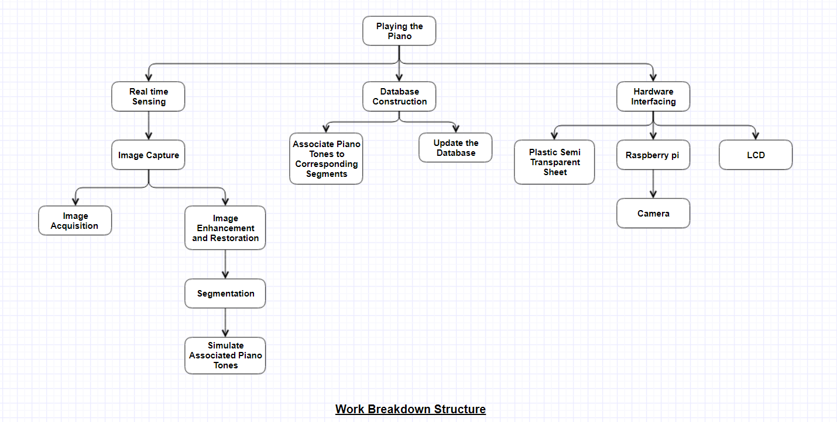

Figure 3.1: Work Breakdown Structure

* 1. **Tools and Technologies Used**

Video is the sequence of the image frames at a fixed rate. First of all, Images would be captured with a simple camera in 2D continuously and would be processed one by one. An HSV color space-based skin filter would be applied on the images for hand segmentation. An intensity-based histogram would be constructed for the wrist end detection and image would be cropped so that resultant image would have only hand pixels. The fingertips would be detected in the cropped hand image and would be marked differently.

**Skin Filter**

An HSV color space-based skin filter would be used on the current image frame for hand segmentation. The skin filter would be used to create a binary image with black background. This binary image would be smoothened using the averaging filter. There can be false positives, to remove these errors the biggest BLOB (Binary Linked Object) is considered as the hand and rest are background. The biggest BLOB represents hand coordinates “1” and “0” to the background [4]. The filtered-out hand image, after removing all errors. The only limitation of this filter is that the BLOB for hand should be the biggest one.

**Wrist End Detection**

To crop the image, we need to find out the direction of hand and wrist end. First of all, an intensity histogram of the binary silhouette would be formed. Histograms functions are: Here imb represents the binary silhouette and m, n represents the row and columns of the matrix imb.

To find the direction of hand, after a 4-way scan of image, we choose the maximum value of “ON” pixels coming out of all scans (“1” in the binary silhouette). It was noted that maximum value of “ON” pixels represents wrist end and opposite end of this scan end would represent the finger end. Similarly, the green bar corresponds to right scan, red bar corresponds to down scan, and pink bar corresponds to up scan of “ON” pixels in the binary silhouette. Now, it is clear that red bar has higher magnitude than other bars. So, we can infer that the wrist end is in downward direction of the frame and consequently the direction of fingers is in the upward direction [8]. Here the direction from wrist to finger is known.

**Hand Cropping**

Hand cropping minimizes the number of pixels to be considered for processing which leads to minimization of computation time. In the histogram generated, it was observed that at the point where wrist ends, a steeping inclination of the magnitude of the histogram starts, whose slope, m can be defined.

The scan would start from the end where skin pixel was found and move till an inclination would be found. The points correspond to the first skin pixel scanning from other three sides were found, crop the image at that points. The equations for cropping the image are:

Where imcrop represents the cropped image, Xmin, Ymin, Xmax, Ymax represent the boundary of the hand in the image. Some results with processing steps for hand cropping. The arrows showed in the main frames indicate the direction of scan which was found from wrist end detection step [7]. In all the histograms it is clear that at the wrist point, a steeping inclination starts in the scanning direction.

**Fingertip Detection**

At this point we have one smaller image which conation only skin pixels (hand gesture shape). We will figure out fingertips in the cropped hand image. Start scan the cropped binary image from wrist to fingers end and calculate the number of pixels for each row or column based on the hand direction in up-down or left-right. Assign the intensity values for each pixel from 1 to 255 in increased manner from wrist to finger end in equal distribution. So, each “ON” pixel on the edges of the fingers would be assigned a high intensity value of 255. Hence all the fingertips contain pixel value 255.

The line having high intensity pixel, is first indexed and check whether differentiated value lie inside a threshold, if it is then it represents a fingertip. The threshold value changes toward the direction of hand. That threshold can be set after the detection of the direction of hand to the finger which we already know. where detected pixels are marked with different color. any direction, only palm should face the camera [11]. The fingertips would be detected irrespective of user orientation. The movement of user’s finger will control the robot hand and its working, by moving hand in front of camera without wearing any gloves or markers.

**DESIGN SPECIFICATIONS**

* 1. **System Architecture**

1. Block Diagram

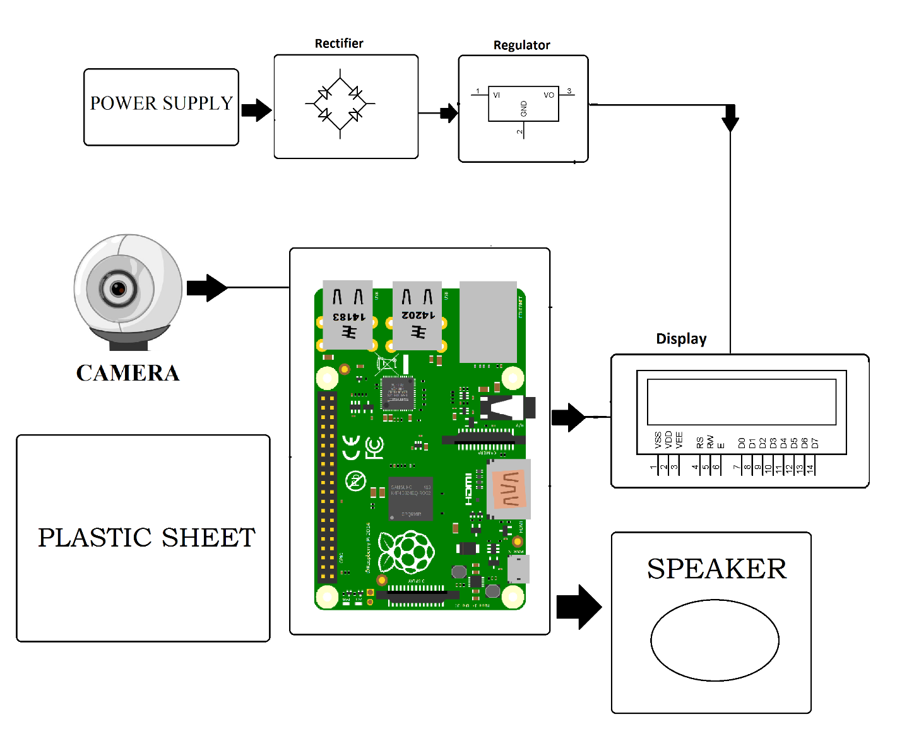

Figure 4.1: Block Diagram

1. 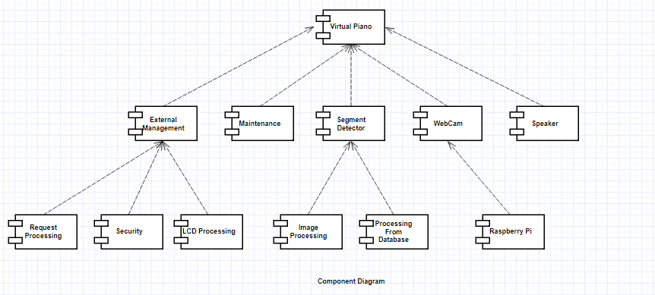Component Diagram

Figure 4.2: Component Diagram

1. Data Centered Architecture

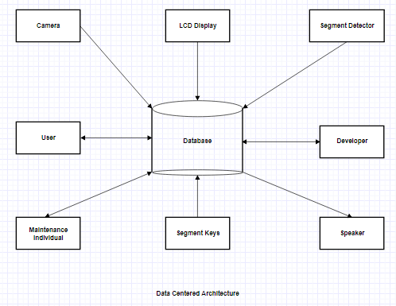

Figure 4.3: Data Centered Architecture

1. 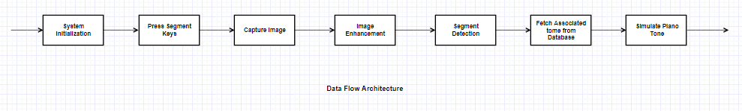Data Flow Architecture

Figure 4.4: Data Flow Architecture

1. Context Diagram

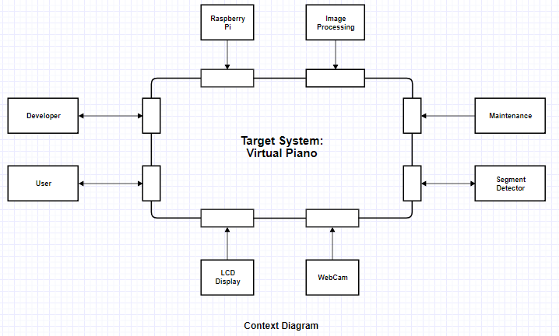

Figure 4.5: Context Diagram

* 1. **Design Level Diagram**

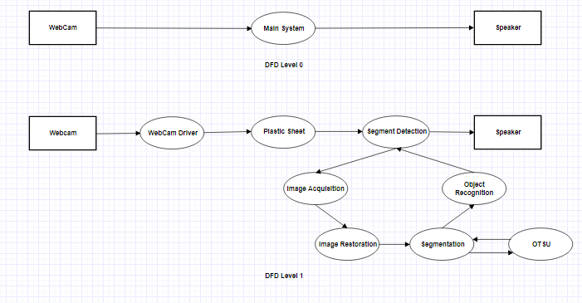

Figure 4.6: Design Level Diagram

* 1. **User Interface Diagrams**

1. 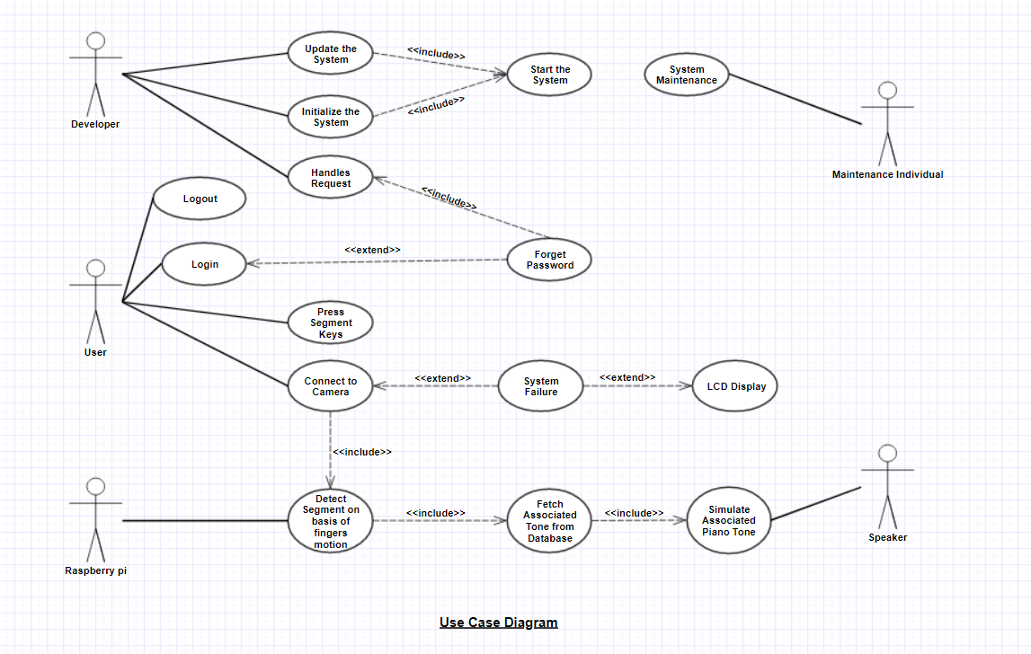Use case diagram

Figure 4.7: Use Case Diagram

1. 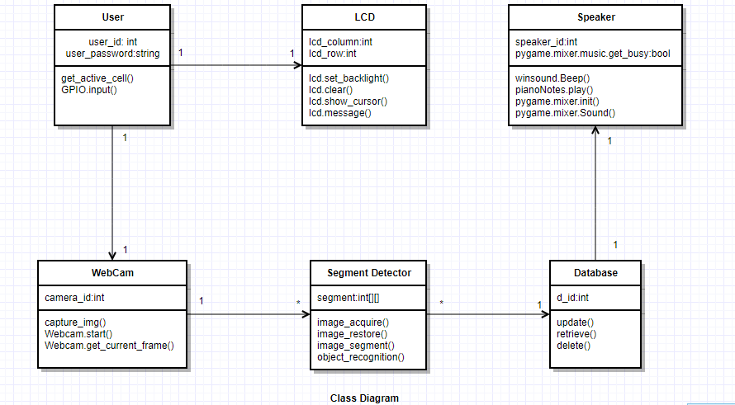Class Diagram

Figure 4.8: Class Diagram

1. 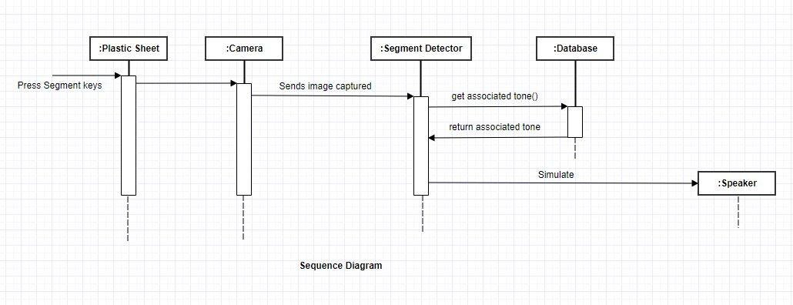Sequence Diagram

Figure 4.9: Sequence Diagram

* 1. **System Screenshots**

1. Semi-Transparent Plastic Sheet

Figure 4.10: Semi-Transparent Plastic Sheet

1. 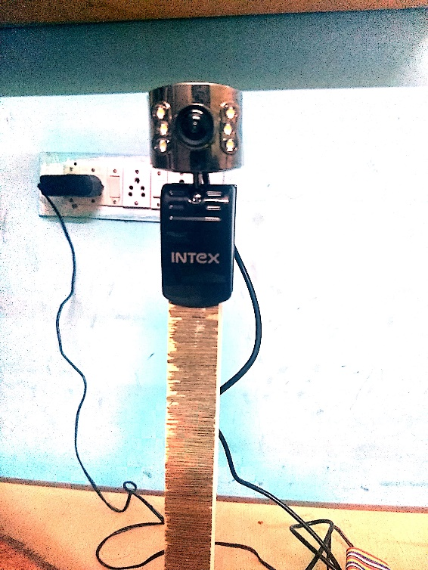Camera attached on wooden mount

Figure 4.11: Camera attached on wooden mount

1. 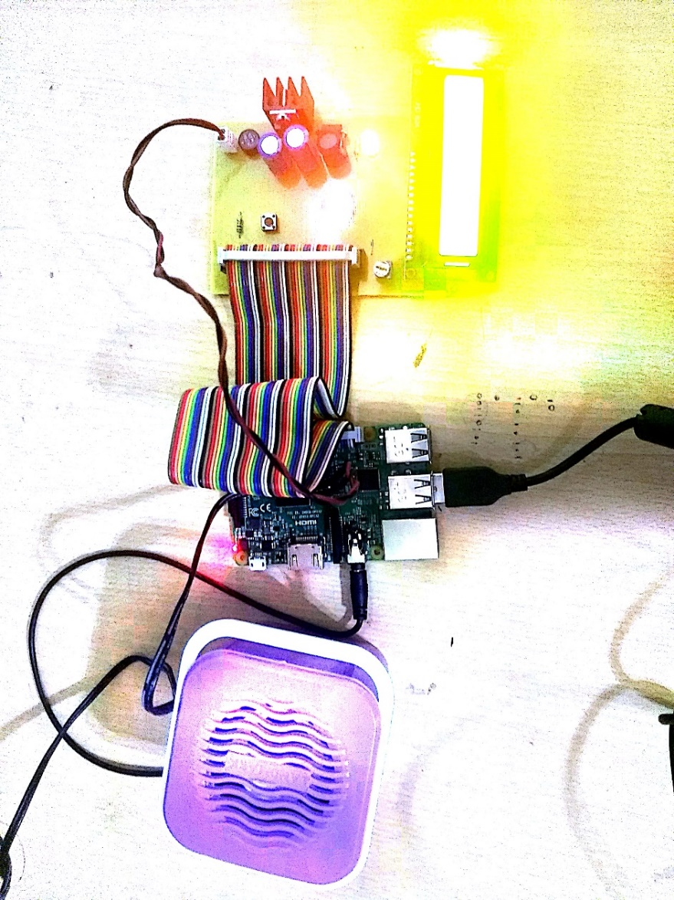Speaker, Raspberry pi and LCD Display

Figure 4.12: Speaker, Raspberry Pi and LCD Display

**IMPLEMENTATION AND EXPERIMENTATION RESULTS**

* 1. **Experimental Setup**

In this project we are making a portable virtual piano that just uses semi-transparent plastic sheet that can be carried anywhere and does not include any electronic components in it. We use a raspberry pi attached to a camera along with the plastic sheet to make a virtual piano. We use image processing to divide the plastic sheet into sections and assign particular tomes to it. We then detect human fingers through the plastic sheet and simulate associate piano tone for each section to play piano tones using a speaker. Thus, we provide a virtual piano which is actually a transparent light weight plastic board that can be carried around roughly.

The Raspberry Pi is attached to a camera, speaker and LCD Display. The LCD Display is connected with a regulator which in turn is connected to the power supply through a rectifier. A rectifier is an electrical device that converts [alternating current](http://en.wikipedia.org/wiki/Alternating_current) (AC), which periodically reverses direction, to [direct current](http://en.wikipedia.org/wiki/Direct_current) (DC), current that flows in only one direction, a process known as rectification. Rectifiers have many uses including as components of [power supplies](http://en.wikipedia.org/wiki/Power_supply) and as [detectors](http://en.wikipedia.org/wiki/Detector_(radio)) of [radio](http://en.wikipedia.org/wiki/Radio) signals. In this project, a bridge rectifier is used because of its merits like good stability and full wave rectification. In positive half cycle only two diodes (1 set of parallel diodes) will conduct, in negative half cycle remaining two diodes will conduct and they will conduct only in forward bias only. All these connections have been made on the PCB Board. A printed circuit board (PCB) mechanically supports and electronically connects electronic or [electrical](https://en.wikipedia.org/wiki/Electrical) components using [conductive](https://en.wikipedia.org/wiki/Electrical_conductor) tracks, pads and other features [etched](https://en.wikipedia.org/wiki/Industrial_etching) from one or more sheet layers of copper [laminated](https://en.wikipedia.org/wiki/Laminated) onto and/or between sheet layers of a [non-conductive](https://en.wikipedia.org/wiki/Insulator_(electricity)) [substrate](https://en.wikipedia.org/wiki/Substrate_(electronics)).

* 1. **Experimental Analysis**
     1. **Data**

We propose a method for identifying a piano keyboard present in the video footage of a standard webcam with the goal of teaching chords, scales and suggested finger positions to a beginner pianist. Our keyboard identification method makes use of binary thresholding, Sobel operators and Hough transforms, as well as proposed algorithms specific to this application, to first find an area resembling a piano keyboard before narrowing the search to detect individual keys [9]. Through the use of our method the keys of a piano keyboard were successfully identified from webcam video footage, with a tolerance to camera movement and occluded keys demonstrated. This result allowed the augmented reality style highlighting of individual keys, and the display of suggested fingering, for various chords and scales.

* + 1. **Performance Parameters**

We are experimenting this Virtual Piano on different test cases. There are majorly two types of test cases- basic test cases and corner test cases. The basic test cases include placing the finger (single finger or multiple fingers) on different segments of piano and checking whether correct tone is coming or not and also verifying the output from LCD screen display. The corner test cases include testing on single finger detection, double finger detection and multi finger detection.

* 1. **Testing Process**
     1. **Test Plan**
        1. **Features to be tested**

We want to test how the Virtual Piano will behave in different scenarios like single finger detection, double finger detection and multi finger detection. In single finger detection, we will place our finger at first segment i.e. Segment C, middle segment i.e. Segment F and last segment i.e. Segment B. In double finger detection, we will place our finger on first and last segment i.e. Segment C and Segment B, middle two segments i.e. Segment F and Segment G and at any two segments, say Segment D and Segment A. Finally, we will check for multi finger detection in which we will place our fingers on three segments, four segments, five segments and six segments in continuous and non-continuous fashion.

* + - 1. **Test Strategy**

For testing on single finger, we are testing by placing the finger on first segment i.e Segment C, the middle segment i.e Segment F and on the last segment, i.e Segment B at different time intervals. For the detection of double fingers, we will be placing the finger on first and last segment i.e Segment C and Segment B, middle two segments i.e Segment F and Segment G and at any two segments, say Segment B and Segment G. This virtual piano can also detect for multiple fingers. For testing this, we have taken many test cases like three segments, four segments, five segments, six segments, etc. In multi-finger detection, we have even included the test cases for detection of fingers in continuous manner as well as detection of fingers in non-continuous manner. The test cases include placing the fingers on three continuous segments i.e Segment B, Segment A and Segment G and again on further three continuous segments i.e Segment F, Segment E and Segment D. We now placed our fingers on three non-continuous segments i.e Segment B, Segment G and Segment C and again on further three non-continuous segments i.e Segment G, Segment F and Segment D. Now we placed our fingers on four segments i.e Segment A, Segment G, Segment F and Segment E and further again on different four segments including Segment G, Segment F, Segment E and Segment D. After the successful detection of four fingers by our virtual piano, we moved towards testing the detection of five fingers by our virtual piano. We now placed our fingers on five different segments i.e Segment A, Segment G, Segment F, Segment E and Segment D. After this we tested the Virtual Piano for the detection of six fingers. We placed our fingers on Segment B, Segment A, Segment G, Segment F, Segment E and Segment D.

It is not necessary to place our fingers on a particular segment for the specified tone to be played. We have used Image Processing to divide our semi-transparent plastic sheet into different segments. Even if we will not place our fingers on a segment and instead place our fingers in the air, the tone will still be played. The semi-transparent plastic sheet has been designed for a beginner so that he can understand the importance of these segments as then he will get the same feeling as he will get while working on an actual piano.

The Virtual Piano is designed in such a manner so that it remains in accordance with the actual piano. With music, there are many different strategies that can help you move quickly to a better understanding. Everyone approaches music differently. Some beginners intuitively grasp complex concepts, others need a little help along the way. Our main aim for designing this virtual piano was to make the beginners understand the complex concepts of piano in an interactive manner getting the taste of technology along with the feel of actual piano.

* + - 1. **Test Techniques**

We have used Boundary Value Analysis and Error Guessing for testing our project. Boundary value analysis is based on testing at the boundaries between partitions. It includes maximum, minimum, inside or outside boundaries, typical values and error values. It is generally seen that a large number of errors occur at the boundaries of the defined input values rather than the centre. It is also known as BVA and gives a selection of test cases which exercise bounding values. This test case design technique complements equivalence partitioning. This software testing technique base on the principle that, if a system works well for these particular values then it will work perfectly well for all values which comes between the two boundary values. If an input condition is a large number of values, the test case should be developed which need to exercise the minimum and maximum numbers. Here, values above and below the minimum and maximum values are also tested. Error guessing is a software testing technique which is based on guessing the error which can prevail in the code. It is an experience-based technique where the test analyst uses his/her or experience to guess the problematic part of the testing application. The technique counts a list of possible errors or error-prone situations. Then tester writes a test case to expose those errors. To design test cases based on this software testing technique, the analyst can use the past experiences to identify the conditions.

* + 1. **Test Cases**

1. Single Finger Detection
2. Finger placed at first segment
3. Finger placed at middle segment
4. Finger placed at last segment
5. Double Finger Detection
6. Fingers placed at first and last segment
7. Fingers placed at middle two segments
8. Fingers placed at any two segments
9. Multi Finger Detection
   * 1. **Test Results**
10. Single Finger Detection
11. Finger placed at first segment i.e. Segment C

Test Result:

Sound is being played corresponding to segment C and the same is being displayed on the LCD screen.

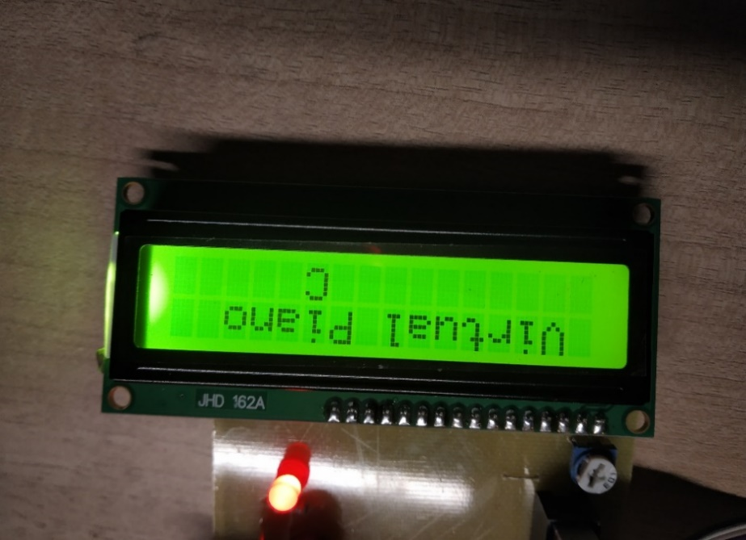

Figure 5.1: Output obtained when finger is placed at Segment C

1. Finger placed at middle segment i.e. Segment F

Test Result:

Sound is being played corresponding to segment F and the same is being displayed on the LCD screen.

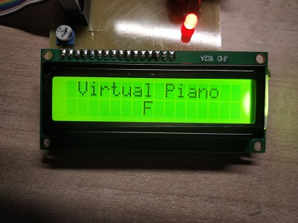

Figure 5.2: Output obtained when finger is placed at Segment F

1. Finger placed at last segment i.e. Segment B

Test Result:

Sound is being played corresponding to segment B and the same is being displayed on the LCD screen.

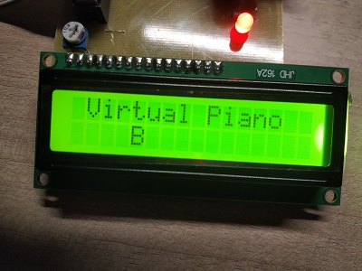

Figure 5.3: Output obtained when finger is placed at Segment B

1. Double Finger Detection
2. Fingers placed at first and last segment i.e. Segments B and C

Test Result:

Sound is being played corresponding to Segments B and C and the same is being displayed on the LCD screen.

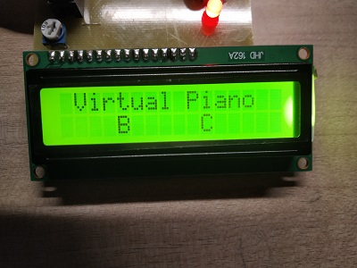

Figure 5.4: Output obtained when fingers are placed at Segments B & C

1. Fingers placed at middle two segments i.e. Segments G and F

Test Result:

Sound is being played corresponding to Segments G and F and the same is being displayed on the LCD screen.

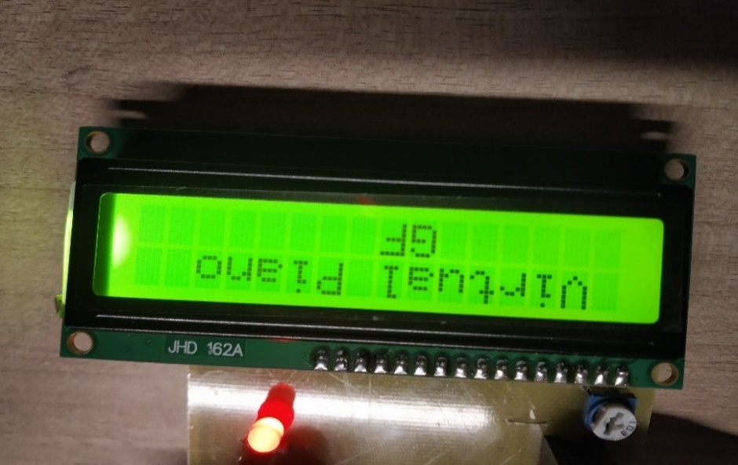

Figure 5.5: Output obtained when fingers are placed at Segments G & F

1. Fingers placed at any two segments, say Segments A and D

Test Result:

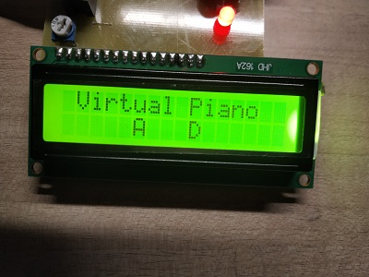Sound is being played corresponding to Segments A and D and the same is being displayed on the LCD screen.

Figure 5.6: Output obtained when fingers are placed at Segments A & D

1. Multi Finger Detection
2. Fingers placed at three segments, say Segments B, A and G

Test Result:

Sound is being played corresponding to Segments B, A and G and the same is being displayed on the LCD Screen.

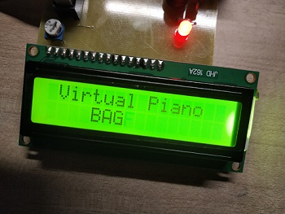

Figure 5.7: Output obtained when fingers are placed at Segments B, A & G

1. Fingers placed at three segments, say Segments F, E and D

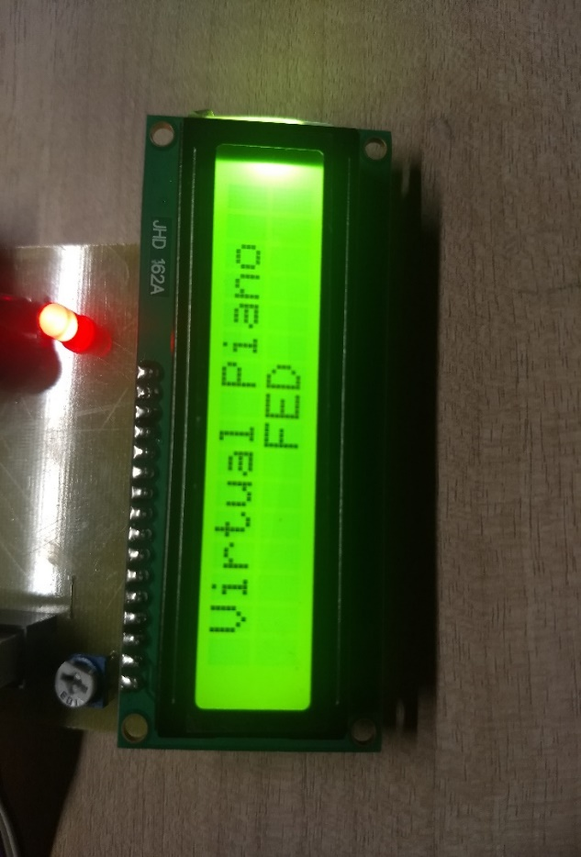Test Result:

Sound is being played corresponding to Segments F, E and D and the same is being displayed on the LCD screen.

Figure 5.8: Output obtained when fingers are placed at Segments F, E & D

1. Fingers placed at three non-continuous segments, say Segments B, G and C

Test Result:

Sound is being played corresponding to non-continuous Segments B, G and C and the same is being displayed on the LCD screen.

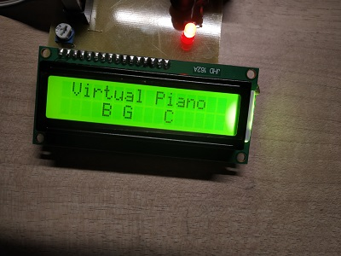

Figure 5.9: Output obtained when fingers are placed at Segments B, G & C

1. Fingers placed at three non-continuous segments, say G, F and D

Test Result:

Sound is being played corresponding to non-continuous Segments G, F and D and the same is being displayed on the LCD screen.

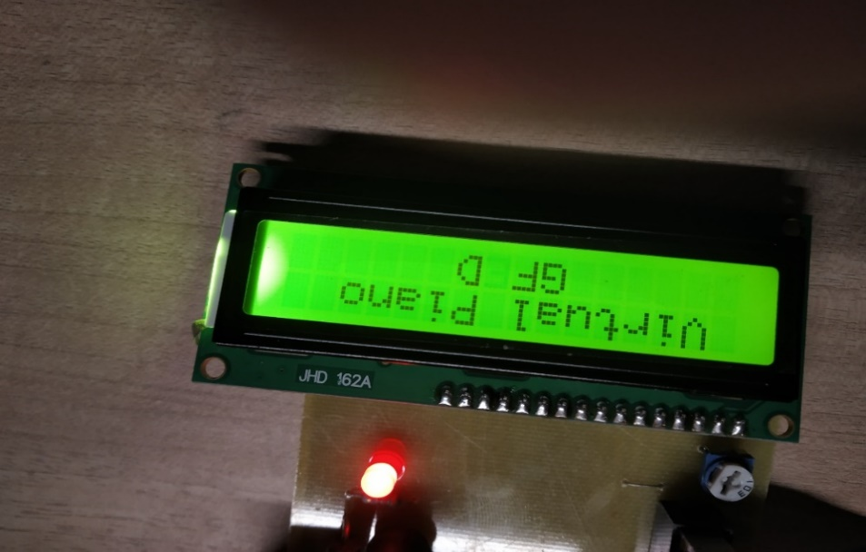zzzzzzzzzzzzzzzz

Figure 5.10: Output obtained when fingers are placed at Segments G, F & D

1. Fingers placed at four segments, say Segments A, G, F and E

Test Result:

Sound is being played corresponding to Segments A, G, F and E and the same is being displayed on the LCD screen.

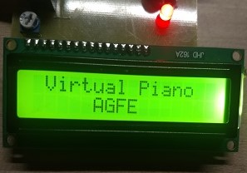

Figure 5.11: Output obtained when fingers are placed at Segments A, G, F & E

1. Fingers placed at four segments, say Segments G, F, E and D

Test Result:

Sound is being played corresponding to Segments G, F, E and D and the same is being displayed on the LCD screen.

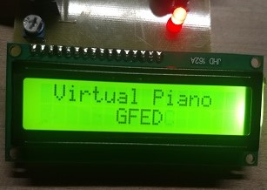

F

Figure 5.12: Output obtained when fingers are placed at Segments G, F, E & D

1. Fingers placed at five segments, say Segments A, G, F, E and D

Test Result:

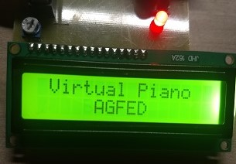Sound is being played corresponding to Segments A, G, F, E and D and the same is being displayed on the LCD screen.

Figure 5.13: Output obtained when fingers are placed at Segments A, G, F, E & D

1. Fingers placed at six segments, say Segments B, A, G, F, E and D

Test Result:

Sound is being played corresponding to Segments B, A, G, F, E and D and the same is being displayed on the LCD screen.

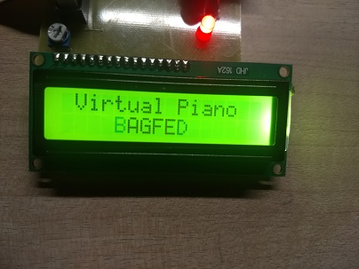F

Figure 5.14: Output obtained when fingers are placed at Segments B, A, G, F, E & D

* 1. **Results and Discussions**

We have got the desired results as shown above. We are experimenting this Virtual Piano on different test cases. There are majorly two types of test cases- basic test cases and corner test cases. The basic test cases include placing the finger (single finger or multiple fingers) on different segments of piano and checking whether correct tone is coming or not and also verifying the output from LCD screen display. The corner test cases include testing on single finger detection, double finger detection and multi finger detection.

For testing on single finger, we are testing by placing the finger on first segment i.e Segment C, the middle segment i.e Segment F and on the last segment, i.e Segment B at different time intervals. For the detection of double fingers, we will be placing the finger on first and last segment i.e Segment C and Segment B, middle two segments i.e Segment F and Segment G and at any two segments, say Segment B and Segment G. This virtual piano can also detect for multiple fingers. For testing this, we have taken many test cases like three segments, four segments, five segments, six segments, etc. In multi-finger detection, we have even included the test cases for detection of fingers in continuous manner as well as detection of fingers in non-continuous manner. The test cases include placing the fingers on three continuous segments i.e Segment B, Segment A and Segment G and again on further three continuous segments i.e Segment F, Segment E and Segment D. We now placed our fingers on three non-continuous segments i.e Segment B, Segment G and Segment C and again on further three non-continuous segments i.e Segment G, Segment F and Segment D. Now we placed our fingers on four segments i.e Segment A, Segment G, Segment F and Segment E and further again on different four segments including Segment G, Segment F, Segment E and Segment D. After the successful detection of four fingers by our virtual piano, we moved towards testing the detection of five fingers by our virtual piano. We now placed our fingers on five different segments i.e Segment A, Segment G, Segment F, Segment E and Segment D. After this we tested the Virtual Piano for the detection of six fingers. We placed our fingers on Segment B, Segment A, Segment G, Segment F, Segment E and Segment D.

It is not necessary to place our fingers on a particular segment for the specified tone to be played. We have used Image Processing to divide our semi-transparent plastic sheet into different segments. Even if we will not place our fingers on a segment and instead place our fingers in the air, the tone will still be played. The semi-transparent plastic sheet has been designed for a beginner so that he can understand the importance of these segments as then he will get the same feeling as he will get while working on an actual piano.

* 1. **Inference Drawn**

In all the test cases specified above, our project works perfectly fine. In all of the above specified test cases, the tone is being played corresponding to the detected segment. The same is verified by the LCD Screen display as well. When the tone was being played corresponding to the detected segment, the same segment was displayed on LCD Screen as well. Our main aim was to test the project on exhaustive test cases. We did the same and tested our project on all possible exhaustive test cases specified as above. On all of these exhaustive test cases, we were getting the correct required output.

* 1. **Validation of Objectives**

1. We are able to assign the respective tones of piano to the corresponding segments of Virtual Piano made using semi-transparent plastic sheet.
2. We are now able to do real time motion detection of fingers using a camera linked with Raspberry pi.
3. We are now able to play the tone assigned to a segment on detection of finger on that particular Segment.

**CONCLUSIONS AND FUTURE DIRECTIONS**

* 1. **Conclusions**

This project is a great example of how the use of Raspberry Pi and Pi camera with Open CV's computer vision algorithms can do wonders in security standards. By compiling the latest version of Open CV, we got access to the latest and most interesting computer vision algorithms like finger recognition, skin filter, wrist end detection, hand cropping and finger tip detection. In this project, we did Soldering of components based on the circuit diagrams decided earlier. We organized all the components based in the circuit diagram. We then finally detected the fingers on the Virtual Piano using our said algorithms and simulated the associated piano tone.

* 1. **Social/Economic Benefits**

1. We propose a portable virtual piano that just uses semi-transparent plastic sheet that can be carried anywhere and does not have any electronic components in it.
2. Large Pianos are prone to damage in travelling and these Virtual Pianos will take care of this issue.
3. Virtual Pianos will be much cheaper than traditional pianos.
4. It will help young children to get a feel for music and will act as a stepping stone for some of the world’s greatest artists.
   1. **Reflections**
5. Understood the workings of Raspberry Pi in detail.
6. Understood the implementation of Ada fruit in Python.
7. Understood the implementation of pygame library in Python.
8. Become proficient in working as an enthusiastic team
   1. **Future Work**
9. Code optimization to improve real time sensing.
10. Improved prototype with proper casing to give it a finishing and premium look.
11. Investigate using other real time sensing algorithms in OpenCV which might be more robust to varied lighting or other conditions.

**PROJECT METRICS**

* 1. **Challenges Faced**

When you start reading this article you may ask yourself: “What is a Virtual Piano?” A virtual piano doesn’t really exist, because it’s made up of semi-transparent plastic sheet, a Raspberry pi, a camera and a speaker and you can play it with your fingers or with a stick. Virtual Piano project is not only a funny game, but the beginning of a road that leads to a new kind of technology. In fact, in a not very distant future, we can imagine that every interface peripheral as a keyboard or a mouse, may be replaced by a projected one, much more portable, quicker and easier to use. In the musical area, with this kind of technology, everyone should be able to play a keyboard or a drum everywhere without carrying heavy instruments.

The application was developed in two steps: first is processing of the sound and second is developing the actual code. For obtaining the necessary sound which has to be added, one has to create and record the audio file for each sound and then to edit that file and after that storing the required files in the necessary directory. A simple way to record electronically a musical sequence, so one can edit it later, comes right from Windows Operating System. One can also find in Windows the “Sound recorder” application. There, after pressing the “Start Recording” button, we play the audio file which contains multiple musical notes. When it’s finished playing, we click on “Stop Recording” and we name our new WMA (Windows Media Audio) file. If we don’t have an audio file containing musical notes, we can “create one” by using an online music application, such as “Virtual Keyboard”, which includes many musical instruments. For editing the WMA file, the usage of the “Adobe Audition” program is required. Also, if by any chance we obtain the audio files in MP3 format, we must convert them into WAV files, in order to have a better sound quality for our musical notes. Audacity is a program that helps us do the conversion only by opening the audio file and saving it with the wanted extension. The *Touch & Listen* application was written using Java 1.7.0_07 in NetBeans IDE 7.4. We used extensively the Java graphical libraries: Swing and AWT.

* 1. **Relevant Subjects**

1. **Internet of Things**

The internet of things, or IoT, is a system of interrelated computing devices, mechanical and digital machines, objects, animals or people that are provided with unique identifiers ([UIDs](https://internetofthingsagenda.techtarget.com/definition/unique-identifier-UID)) and the ability to transfer data over a network without requiring human-to-human or human-to-computer interaction.

A [thing](https://internetofthingsagenda.techtarget.com/definition/thing-in-the-Internet-of-Things) in the internet of things can be a person with a heart monitor implant, a farm animal with a [biochip transponder](https://internetofthingsagenda.techtarget.com/definition/injectable-ID-chip-biochip-transponder), an automobile that has built-in [sensors](https://whatis.techtarget.com/definition/sensor) to alert the driver when tire pressure is low or any other natural or man-made object that can be assigned an IP address and is able to transfer data over a network.

Increasingly, organizations in a variety of industries are using IoT to operate more efficiently, better understand customers to deliver enhanced customer service, improve decision-making and increase the value of the business.

**How IoT works**

An IoT ecosystem consists of web-enabled smart devices that use embedded processors, sensors and communication hardware to collect, send and act on data they acquire from their environments. [IoT devices](https://internetofthingsagenda.techtarget.com/definition/IoT-device) share the sensor data they collect by connecting to an IoT gateway or other edge device where data is either sent to the cloud to be analyzed or analyzed locally. Sometimes, these devices communicate with other related devices and act on the information they get from one another. The devices do most of the work without human intervention, although people can interact with the devices -- for instance, to set them up, give them instructions or access the data. The connectivity, networking and communication protocols used with these web-enabled devices largely depend on the specific IoT applications deployed.

**Benefits of IoT**

The internet of things offers a number of benefits to organizations, enabling them to monitor their overall business processes, improve the customer experience, save time and money, enhance employee productivity, integrate and adapt business models, make better business decisions and generate more revenue.

1. **Image Processing**

Image processing is a method to perform some operations on an image, in order to get an enhanced image or to extract some useful information from it. It is a type of signal processing in which input is an image and output may be image or characteristics/features associated with that image. Nowadays, image processing is among rapidly growing technologies. It forms core research area within engineering and computer science disciplines too.

Image processing basically includes the following three steps:

1. Importing the image via image acquisition tools.
2. Analyzing and manipulating the image.
3. Output in which result can be altered image or report that is based on image analysis.

There are two types of methods used for image processing namely, analogue and digital image processing. Analogue image processing can be used for the hard copies like printouts and photographs. Image analysts use various fundamentals of interpretation while using these visual techniques. Digital image processing techniques help in manipulation of the digital images by using computers. The three general phases that all types of data have to undergo while using digital technique are pre-processing, enhancement, and display, information extraction.

In this lecture we will talk about a few fundamental definitions such as image, digital image, and digital image processing. Different sources of digital images will be discussed and examples for each source will be provided. The continuum from image processing to computer vision will be covered in this lecture. Finally, we will talk about image acquisition and different types of image sensors.

1. **Embedded System**

An embedded system is a dedicated computer system designed for one or two specific functions. This system is embedded as a part of a complete device system that includes hardware, such as electrical and mechanical components. The embedded system is unlike the general-purpose computer, which is engineered to manage a wide range of processing tasks.

Because an embedded system is engineered to perform certain tasks only, design engineers may optimize size, cost, power consumption, reliability and performance. Embedded systems are typically produced on broad scales and share functionalities across a variety of environments and applications.

Embedded systems are managed by single or multiple processing cores in the form of microcontrollers or digital signal processors (DSP), field-programmable gate arrays (FPGA), application-specific integrated circuits (ASIC) and gate arrays. These processing components are integrated with components dedicated to handling electric and/or mechanical interfacing.

An embedded system's key feature is dedication to specific functions that typically require strong general-purpose processors. For example, router and switch systems are embedded systems, whereas a general-purpose computer uses a proper OS for routing functionality. However, embedded routers function more efficiently than OS-based computers for routing functionalities. Commercial embedded systems range from digital watches and MP3 players to giant routers and switches. Complexities vary from single processor chips to advanced units with multiple processing chips.

* 1. **Interdisciplinary Knowledge Sharing**

In this project, we have used knowledge of two disciplines of engineering i.e. Computer Engineering and Electronics and Communication Engineering. This project includes both the software and hardware components. The software part is completed in accordance with the principles of Computer Engineering and the hardware part is completed in accordance with the principles of Electronics and Communication Engineering.

* 1. **Peer Assessment Matrix**

|  |  |  |  |
| --- | --- | --- | --- |
| **Evaluation of** | | Akshay Sharma | Abhishek Sharma |
| **Evaluation By** | Akshay Sharma | 5 | 5 |
| Abhishek Sharma | 5 | 5 |

Table 7.1: Peer Assessment Matrix

* 1. **Work Schedule**

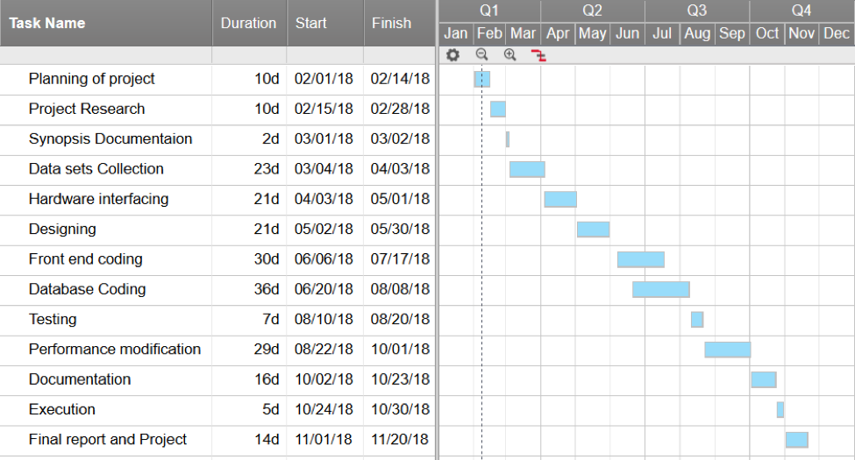

Table 7.2: Work Schedule

* 1. **Student Outcomes Description and Performance Indicators (A-K Mapping)**

|  |  |  |
| --- | --- | --- |
| **SO** | **Description** | **Outcome** |
| A1 | Applying mathematical concepts to obtain analytical and numerical solutions. | An ability to apply knowledge of mathematics, science and engineering. |
| A2 | Applying basic principles of science towards solving engineering problems. | An ability to apply knowledge of mathematics, science and engineering. |
| A3 | Applying engineering techniques for solving computing problems. | An ability to use techniques, skills and modern engineering tools necessary for engineering practice. |
| B1 | Identify the constraints, assumptions and models for the problems. | An ability to design a system, component or a process to meet desired needs within a realistic constraint such as economic, environmental, social, political, ethical, health, safety, manufacturability and sustainability. |
| B2 | Use appropriate methods, tools and techniques for data collection. | An ability to formulate, identify and solve engineering problems. |
| B3 | Analyze and interpret results with respect to assumptions, constraints and theory. | An ability to design a system, component or a process to meet desired needs within a realistic constraint such as economic, environmental, social, political, ethical, health, safety, manufacturability and sustainability. |
| C1 | Design software system to address desired needs in different problem domains. | An ability to design and conduct experiments, as well as to analyze and interpret data. |
| C2 | Can understand scope and constraints such as economic, environmental, social, political, ethical, health and safety, manufacturability, and sustainability. | An ability to design a system, component or a process to meet desired needs within a realistic constraint such as economic, environmental, social, political, ethical, health, safety, manufacturability and sustainability. |
| D1 | Fulfill assigned responsibility in multidisciplinary teams. | An ability to function on multi-disciplinary teams. |
| D2 | Can play different roles as a team player. | A willingness to assume leadership roles and responsibilities. |
| E1 | Identify engineering problems. | The broad education is necessary to understand the impact of engineering solutions in a global, economic, environmental and societal context. |
| E2 | Develop appropriate models to formulate solutions. | An ability to apply knowledge of mathematics, science and engineering. |
| E3 | Use analytical and computational methods to obtain solutions. | An ability to apply knowledge of mathematics, science and engineering. |
| F1 | Showcase professional responsibility while interacting with peers and professional communities. | To understand professional and ethical responsibility. |
| F2 | Able to evaluate the ethical dimensions of a problem. | To understand professional and ethical responsibility. |
| G1 | Produce a variety of documents such as laboratory or project reports using appropriate formats. | An ability to apply knowledge of mathematics, science and engineering. |
| G2 | Deliver well-organized and effective oral presentation. | An ability to communicate effectively, both orally and writing. |
| H1 | Aware of environmental and societal impact of engineering solutions. | An ability to design a system, component or a process to meet desired needs within a realistic constraint such as economic, environmental, social, political, ethical, health, safety, manufacturability and sustainability. |
| H2 | Examine economic tradeoffs in computing systems. | An ability to use techniques, skills and modern engineering tools necessary for engineering practice. |
| I1 | Able to explore and utilize resources to enhance self-learning. | A recognition of the need for, and an ability to engage in lifelong learning. |
| I2 | Recognize the importance of life-long learning. | A recognition of the need for, and an ability to engage in lifelong learning. |
| J1 | Comprehend the importance of contemporary issues. | A knowledge of contemporary issues. |
| K1 | Write code in different programming languages. | An ability to design and conduct experiments, as well as analyze and interpret data. |
| K2 | Apply different data structures and algorithmic techniques. | An ability to communicate effectively, both orally and writing. |
| K3 | Use software tools necessary for computer engineering domain | An ability to use the techniques, skills and modern engineering tools necessary for engineering practice. |

Table 7.3: Student Outcomes Description and Performance Indicators (A-K Mapping)

* 1. **Brief Analytical Assessment**

Video is the sequence of the image frames at a fixed rate. First of all, Images would be captured with a simple camera in 2D continuously and would be processed one by one. An HSV color space-based skin filter would be applied on the images for hand segmentation. An intensity-based histogram would be constructed for the wrist end detection and image would be cropped so that resultant image would have only hand pixels. The fingertips would be detected in the cropped hand image and would be marked differently.

**Skin Filter**

An HSV color space-based skin filter would be used on the current image frame for hand segmentation. The skin filter would be used to create a binary image with black background. This binary image would be smoothened using the averaging filter. There can be false positives, to remove these errors the biggest BLOB (Binary Linked Object) is considered as the hand and rest are background. The biggest BLOB represents hand coordinates “1” and “0” to the background [4]. The filtered-out hand image, after removing all errors. The only limitation of this filter is that the BLOB for hand should be the biggest one.

**Wrist End Detection**

To crop the image, we need to find out the direction of hand and wrist end. First of all, an intensity histogram of the binary silhouette would be formed. To find the direction of hand, after a 4-way scan of image, we choose the maximum value of on pixels coming out of all scans (“1” in the binary silhouette). it was noted that maximum value of “ON” pixels represents wrist end and opposite end of this scan end would represent the finger end. Similarly, the green bar corresponds to right scan, red bar corresponds to down scan, and pink bar corresponds to up scan of „on‟ pixels in the binary silhouette. Now, it is clear that red bar has higher magnitude than other bars. So, we can infer that the wrist end is in downward direction of the frame and consequently the direction of fingers is in the upward direction [8]. Here the direction from wrist to finger is known.

**Hand Cropping**

Hand cropping minimizes the number of pixels to be considered for processing which leads to minimization of computation time. In the histogram generated, it was observed that at the point where wrist ends, a steeping inclination of the magnitude of the histogram starts. The scan would start from the end where skin pixel was found and move till an inclination would be found. The points correspond to the first skin pixel scanning from other three sides were found, crop the image at that points. Where micro represents the cropped image, Xmin, Ymin, Xmax, Ymax represent the boundary of the hand in the image. Some results with processing steps for hand cropping. The arrows showed in the main frames indicate the direction of scan which was found from wrist end detection step [7]. In all the histograms it is clear that at the wrist point, a steeping inclination starts in the scanning direction.

**Fingertip Detection**

At this point we have one smaller image which conation only skin pixels (hand gesture shape). We will figure out fingertips in the cropped hand image. Start scan the cropped binary image from wrist to fingers end and calculate the number of pixels for each row or column based on the hand direction in up-down or left-right. Assign the intensity values for each pixel from 1 to 255 in increased manner from wrist to finger end in equal distribution. So, each “on” pixel on the edges of the fingers would be assigned a high intensity value of 255. The line having high intensity pixel, is first indexed and check whether differentiated value lie inside a threshold, if it is then it represents a fingertip. The threshold value changes toward the direction of hand. That threshold can be set after the detection of the direction of hand to the finger which we already know where detected pixels are marked with different color in any direction, only palm should face the camera. The fingertips would be detected irrespective of user orientation [11]. The movement of user’s finger will control the robot hand and its working, by moving hand in front of camera without wearing any gloves or markers.

**REFERENCES**

|  |  |
| --- | --- |
| [1] | A. Oka and M. Hashimoto, "Marker-less piano fingering recognition using sequential depth images", 19th Korea-Japan Joint Workshop on Frontiers of Computer Vision, pp. 1-4, 2013. |
| [2] | M. Sotirios and P. Georgios, "Computer vision method for pianist's fingers information retrieval," presented at the Proceedings of the 10th International Conference on Information Integration and Web-based Applications & Services, Linz, Austria, pp. 5-8, 2008. |
| [3] | C.-C. Lin and D. S.-M. Liu, "An intelligent virtual piano tutor," in Proceedings of the ACM international conference on Virtual reality continuum and its applications, Hong Kong, China, pp. 3-8, 2006. |
| [4] | C. Deaker and R. Green, "A Computer Vision Method of Piano Tutoring, Without the Piano," Canterbury University, pp. 2-4, 2011. |
| [5] | C.-H. Yeh, W.-Y. Tseng, J.-C. Bai, R.-N. Yeh, S.-C. Wang, and P.-Y. Sung, "Virtual Piano Design via Single-View Video Based on Multifinger Actions Recognition," the 3rd International Conference on Human-Centric Computing, pp. 1-5, 2010. |
| [6] | F. Huang, Y. Zhou, Y. Yu, Z. Wang, and S. Du, "Piano AR: A Markerless Augmented Reality Based Piano Teaching System", International Conference on Intelligent Human-Machine Systems and Cybernetics, pp. 47-52, 2011. |
| [7] | D. O. Gorodnichy and A. Yogeswaran, "Detection and tracking of pianist hands and fingers", the 3rd Canadian Conference on Computer and Robot Vision, pp. 62-63, 2006. |
| [8] | K. Huang, E. Y. L. Do, and T. Starner, "PianoTouch: A wearable haptic piano instruction system for passive learning of piano skills, 12th IEEE International Symposium on Wearable Computers, pp. 41-44, 2008. |
| [9] | Adam Goodwin, Richard Green, "Key detection for a virtual piano teacher", Image and Vision Computing New Zealand (IVCNZ) 28th International Conference of, pp. 282-287, 2013 |
| [10] | C. von Hardenberg, F. Berard, "Bare-hand human-computer interaction", Proceedings of the workshop on Perceptive user interfaces*,* pp. 1-8, 2001*.* |
| [11] | Boga Vishal, K Deepak Lawrence, "Paper piano — Shadow analysis-based touch interaction", Man and Machine Interfacing (MAMI) 2nd International Conference on, pp. 1-6, 2017. |
| [12] | Mohammad Akbari, Jie Liang, Howard Cheng, "A real-time system for online learning-based visual transcription of piano music", Multimedia Tools and Applications, vol. 77, pp. 25513, 2018. |
| [13] | Chutisant Kerdvibulvech, Augmented Reality, Virtual Reality, and Computer Graphics, vol. 10325, pp. 251, 2017. |
| [14] | D. Schwarz, S. Britton, R. Cahen, T. Goepfer. Musical Applications of Real-Time Corpus-Based Concatenative Synthesis. International Computer Music Conference (ICMC) (Copenhagen, Denmark), pp. 23, 2007. |